***<***Full Project Title [Campus(es)]> Final Report

**Contents**

**Section 1: Review the Problem** 3

***Business Case*** 3

***Current High-level Process Diagram*** 3

***Problem Statement*** 3

***Objective Statement*** 3

***In Scope*** 3

***Out of Scope*** 3

***Project Timeline*** 3

***Project Team*** 4

***Agreement*** 4

**Section 2: Assess the Current State** 5

***Current State Process Map*** 5

***Opportunities for Improvement*** 5

**Section 3: Plan for Change** 6

***Future State Process Map*** 6

***Suggested Improvements*** 6

***Final Recommendations for Improvement*** 6

**Section 4: Implement Changes** 7

***Solution Action Plan*** 7

**Section 5: Determine Success** 8

***Outcome*** 8

***Implementation Follow-up*** 8

# **Section 1: Review the Problem**

## ***Business Case***

<Give a detailed business case for this project describing why this project is important.>

## ***Current High-level Process Diagram***

<Provide a high-level flow/map using SmartArt below or attach/link to a full SIPOC diagram. Optional, but recommended.>

## ***Problem Statement***

<Detail when the problem has been observed, what the problem is, the magnitude of the problem, and the impact/consequence of the problem.>

## ***Objective Statement***

<The statement should quantify specific expectations and requirements of the final improvement, service, or product. Outline expected outputs and outcomes by indicating improvement targets, product requirements, service qualities, and expected timeframes. Use the SMART guideline for writing the Objective Statement and then specify the Outputs and Outcomes for Customers.>

AND/OR

<Identify the key output metric to be improved using below table. *Remove table otherwise.*>

|  |  |  |  |
| --- | --- | --- | --- |
| **Metric** | **Current** | **Target** | **% Change** |
|  |  |  |  |
|  |  |  |  |
|  |  |  |  |

## ***In Scope***

<Provide a brief description of what is in scope for this engagement. Focus scope description on process boundaries or specific constraints (e.g., excluding Civil Service Employee Class), not project deliverables (e.g., Charter, Project Plan, etc.).>

## ***Out of Scope***

<Provide a brief description of what is out of scope for this project.>

## ***Project Timeline***

<Provide expected start and end dates for each phase of the methodology used, using the table below.>

|  |  |  |
| --- | --- | --- |
| **Phase** | **Expected Start Date** | **Expected End Date** |
| **Review –** Review the problem |  |  |
| **Assess –** Assess the current process |  |  |
| **Plan –** Plan for change |  |  |
| **Implement –** Implement the change |  |  |
| **Determine –** Determine the success |  |  |

## ***Project Team***

|  |  |  |
| --- | --- | --- |
| **Role** | **Name(s)** | **Estimated Commitment** |
| Core Project Team Members |  |  |
|  |
|  |
|  |
|  |
| BPI Project Facilitator |  |  |
| BPI Project Analyst |  |  |

## ***Agreement***

|  |  |  |
| --- | --- | --- |
| **Role** | **Name(s)** | **Date** |
| Project Sponsor |  |  |
| Process Owner |  |  |
| BPI Project Facilitator |  |  |

# **Section 2: Assess the Current State**

<Briefly summarize the current state of the process, potentially including key process metrics (e.g., number of steps, number of participants/unit boundaries, lead time, cycle time, transaction volume, etc.), charts illustrating process metrics, summary of opportunities for improvement, etc.>

## ***Current State Process Map***

<insert link to process map here> 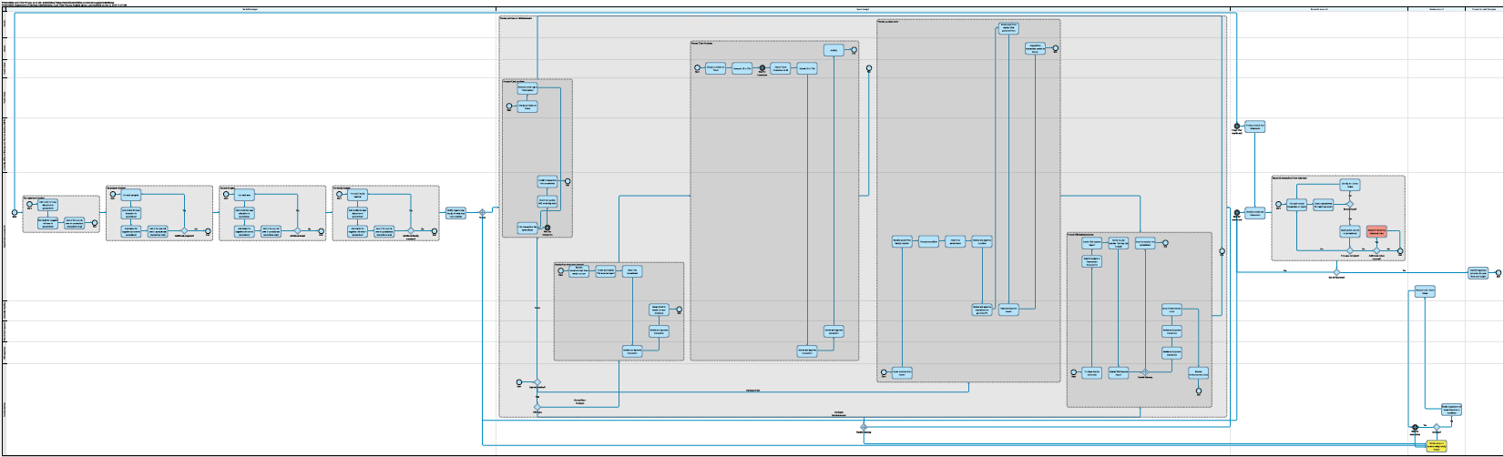

## ***Opportunities for Improvement***

<Briefly summaries the opportunities for improvement identified during the Assess phase. If issues have been categorized, group each category in separate tables and provide a brief description of the category of issue.>

|  |  |
| --- | --- |
| **<Category 1 Issue> - <brief description of category 1>** | |
| C1.1 | <Issue 1 Text> |
| C1.2 | <Issue 2 Text> |

|  |  |
| --- | --- |
| **<Category 2 Issue> - <brief description of category 1>** | |
| C2.1 | <Issue 1 Text> |
| C2.2 | <Issue 2 Text> |

# **Section 3: Plan for Change**

<Briefly summarize the results of the Plan phase, potentially including number of recommendations, highlighting the most impactful recommendations, describing how the recommendations were developed (e.g., focus groups, etc.), key process metrics for the future state map, etc.>

## ***Future State Process Map***

<Optional - insert link to process map here, if a future or ideal state map is developed> 

## ***Suggested Improvements***

<Optional – Briefly summarize any suggested improvements for the projects or how the suggested improvements were developed. This section might be useful if focus groups identify a number of improvement ideas that are later refined by the project team. If improvement ideas have been categorized, group each category in separate tables and provide a brief description of the category of ideas.>

|  |  |  |
| --- | --- | --- |
| <Category 1 Improvement Idea> - <brief description of category 1> | | Related Issue |
| C1.1 | <Improvement Idea 1 Text> | <Issue ID(s)> |
| C1.2 | <Improvement Idea 2 Text> | <Issue ID(s)> |

## ***Final Recommendations for Improvement***

|  |  |  |  |
| --- | --- | --- | --- |
| Rank # | Describe Potential Solutions | Category | Related Issue(s) |
| 1 | **<Brief description of recommendation 1>** - <brief description of how the recommendation will address the project goal or problem statement>. | <Category> |  |
| 2 | **<Brief description of recommendation 2>** - <brief description of how the recommendation will address the project goal or problem statement>. | <Category> |  |

# **Section 4: Implement Changes**

<Briefly summarize the key components of the implementation plan (i.e., number of action items, duration of plan, what will be accomplished in short-term, medium-term, and long-term).>

## ***Solution Action Plan***

|  |  |  |  |
| --- | --- | --- | --- |
|  | Actions Required for Completion | Action Owner | Scheduled Completion |
| 1.0 | **<Brief description of recommendation 1>** | <owner> | <due date> |
| 1.1 | <Action item 1 for recommendation 1> | <owner> | <due date> |
| 1.2 | <Action item 2 for recommendation 1> | <owner> | <due date> |
|  | | | |
| 2.0 | **<Brief description of recommendation 2>** | <owner> | <due date> |
| 2.1 | <Action item 1 for recommendation 2> | <owner> | <due date> |
| 2.2 | <Action item 2 for recommendation 2> | <owner> | <due date> |
|  | | | |

# **Section 5: Determine Success**

## ***Outcome***

<Summary the expected or realized results of this project. Include the number of recommendations and action items, as well as any expected or realized performance metric improvements (i.e., expected or realized changes to the metrics identified in Section 1). Include any other notable accomplishments of this project (e.g., improved communication with all participants, identified future improvement areas, etc.).>

## ***Implementation Follow-up***

<Describe the follow up schedule to check in on the team regarding implementation and any specific issues that might require outside help. This should be established before or at the close of the project.>