Requisition, Purchase Orders & Invoice Vouchers Universe
Quick Reference Guide
EDW – Finance – Purchase Order Invoices

Who should use this universe?
- Business Managers
- Department or Unit purchasing coordinators
- Anyone interested in Requisitions, Purchase Orders, and Invoice Vouchers

What types of business questions can I answer using this universe?
- I would like a list of Requisitions for my unit.
- I would like a list of Purchase Orders and related Invoice Vouchers for my unit.
- I would like a list of all Invoice Vouchers and the Bank check numbers and amounts that paid for them.
- What commodities has my unit purchased in the last 12 months?

Universe Description
This universe is intended to list documents and explore the relationships between Requisition documents, Purchase Order documents, Invoice Voucher documents, and Checks that paid for them. In addition, this universe will also facilitate basic commodity analysis.

Data Included in the Purchase Order Universe
- Requisition document number
- Purchase Order document number
- Invoice Voucher & Bank Check document number
- Purchase Order type
- Vendor Id & name
- Commodity code & description
- Document net amounts
- PCard Cardholder Department Information

Universe Structure
The Purchasing universe contains six classes of objects. Each class represents a ‘context’, a group of objects intended to be used together.

The contexts, or object classes, are setup similarly to the normal business flow of the data. Consider the purchasing process as it unfolds from left to right. First, a Requisition is created. Second, a Purchase Order is created. Third, Receiving & Returns are created, where necessary. Fourth, an Invoice Voucher is created. Finally, the IV is paid with a Check.

Therefore, based on this general principle and the natural state of the data, the objects have been placed in contexts following this process flow. The six contexts (labeled C1 thru C6) are as follows:
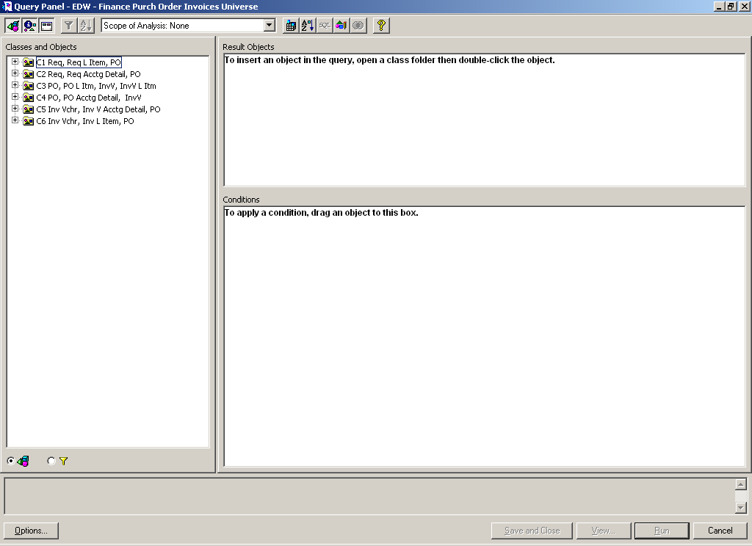

Context 1: Requisition Header, Requisition Line Items, Purchase Order Header, Receivings, Returns

Context 2: Requisition Header, Requisition Accounting Detail, Purchase Order Header, Requisition CFOAPAL, Receivings, Returns

Context 3: Purchase Order Header, PO Line Items, Receivings, Invoice Voucher Header, IV Line Items, Returns

Context 4: Purchase Order Header, Receivings, PO Accounting Detail, PO CFOAPAL, Invoice Voucher Header, Returns

Context 5: Invoice Voucher Header, IV Accounting Detail, Purchase Order Header, Receivings, Bank Check, Returns

Context 6: Invoice Voucher Header, IV Line Items, Purchase Order Header, Receivings, Returns

Universe Tips & Tricks
- This universe only includes posted Requisitions, Purchase Orders, and Invoice Vouchers. That means the source document must have been created, finished, approved and posted to the financial ledgers to appear in the universe.
- This universe displays data similarly to the normal business flow. For example, from Requisition, to Purchase order, to Invoice voucher, to check.
- This universe contains 6 main folders of objects. Do not try to mix and match objects between the 6 folders. Errors or unpredictable data will result.
- Transaction date is linked to the “Time Periods”.
- Using “show list of values” builds a unique list of values from the data. This can take time but should show a list of all available values. This technique may illuminate Banner source data of suspect quality. For example, dates where you would expect values like 7/11/2003 and you instead see 7/11/0203.
- Remember that just because there is a Purchase Order does not mean there is a Requisition. Travel vouchers are a perfect example. When a University employee receives a travel reimbursement, no Requisition or Purchase Order was ever associated with that Invoice Voucher.
- Remember that there is often a ‘one-to-many’ relationship between documents in the purchasing process. For example, one Purchase Order many have many Invoice Vouchers. Each Invoice Voucher may have many checks.
- The Bank Check object is located in the C5 context only. It can be found as a sub-class of the Invoice Voucher Accounting Detail class.
- You will not find Line Item Detail and Accounting Detail (CFOAPALs) in the same object class. Please do not attempt to use objects from these classes in the same query.
- Generally, queries will show you documents based on the business process flow – from left to right as mentioned above. For example, all Requisitions that meet the specified conditions will appear. However, only PO’s that are associated with those Requisitions will appear.
- The exception to this general rule is the C6 context. The C6 context will allow a user to query from the Invoice Voucher back to the PO from right to left. Therefore, all Invoice Vouchers that meet the specified conditions will appear. However, only PO’s that are associated with those IV’s will appear.

Data Quality Advisories

- Banner allows date data to be entered in unanticipated formats. Requisition order date and Invoice Voucher date fields have data with bad business dates. What you expect: 01/01/2004, samples of what you get: 01/01/200 or 3/26/404. The data owners have said this will not be altered in the source.
- In October 2003, the Banner Accounts Payable module experienced processing complications that resulted in the creation of operationally unacceptable data. To remedy the problem, UI-Integrate was able to rebuild the tables in Banner relating to check processing. Rebuilding these tables caused discrepancies between the Banner transaction history tables and the Banner check processing tables for checks processed prior to October 2003. Two examples of anomalous data that resulted are below:
Example 1: Check Number C0002684
The check detail data in the Banner Accounts Payable module (Banner table FABCHKA) and the check detail data stored in the Banner Ledgers (Banner tables FBBTRNH and FGBTRND) do not match. Although a row for this check exists in each set of tables, the data does not correspond. This data is found in the Data Warehouse in the T_BANK_CHK_INV_VCHR_DETL, T_POST_TRAN, and T_GL_DETL respectively.
Example 2: Check Number C0004665
This check is recorded as canceled in the Banner table FGBTRNH. However, no row exists for the original creation of the check. In normal circumstances, one may expect to find an entry for both the creation and the cancellation of the check. The General Ledger detail data for this check is similarly affected. This data can be found in the T_POST_TRAN and T_GL_DETL tables in the Data Warehouse.
UI-Integrate has advised Decision Support that the data in the check tables (T_BANK_CHK and T_BANK_CHK_INV_VCHR_DETL) is valid and correct. In addition, the EDW Ledger Summary tables T_OL_SUM and T_GL_SUM are in balance with the check tables. However, the T_POST_TRAN and T_GL_DETL tables contain anomalous and potentially invalid records. Be aware of the potential for differences in data between the check tables and the Ledger detail tables for checks processed prior to October 2003

