
Pending Degree List
College/OAR Training Guide

Training Session

Table of Contents

General (Business Overview) 3
Banner PDL Gaps 3
The Solution 3
Conversion Impact 4
Training and Communications Impact 4
AITS Web Pages 5
Batch Process 5
AppWorx 5
Reporting 5
Application Flow/Description 6
On-Line Processing 10
Page Flow Diagram 10
Security 11
Pending Degree Initial Page 13
OAR/COLLEGE PAGES 14
Add/Search By Student UIN Page 14
Search By Pending Degree Data Page 19
Pending Degree Summary Page 23
Pending Degree Detail Page 26
Primary Curriculum Page 31
Secondary Curriculum Page 33
View/Maintain Honors 36
BANNER STUDENT WEB SELF SERVICE PAGES 43
Banner Student Web Self Service Main Menu 43
Graduation Information Web Page (Urbana Campus) 44
Select Pending Degree Graduation Term Web Page 45
Select Pending Degree Period Web Page 46
Add Pending Degree Web Page 47
Batch Processing 53
Program Description 53
Frequency 53
Parameters 53
APPWORX 54
Business Logic / Calculation Rules 55
Batch Processing Overview 56
Reports To Be Generated By Report Team 58
Pending Degree List Report 58
Potential Attendee Commencement (UIC & UIUC) 58
Commencement Program Report (UIC & UIUC) 58
Potential Bronze Tablet Recipients (UIUC) 58
Potential Bronze Tablet Recipients 110+ hours (UIUC) 58
General Student Primary/Secondary Curriculum vs. Student Degree Primary/Secondary Curriculum 59

General (Business Overview)
The campuses need to utilize an application to de-centralize the work of graduation processing from the OAR office to the college offices and to allow the OAR office to maintain exclusive maintenance of actual student degrees that will appear on a printed transcript. This application was known as the Pending Degree List application at UIUC (further referred to as PDL). The PDL allows a student to submit his or her intent to graduate via a web-link. This action by the student inserts a “pending” degree record into PDL with the student’s current curriculum. The student’s are allowed to insert their intent to graduate up to a certain date determined by OAR. Either before or after this date has passed, authorized college office and OAR users are also allowed to insert “pending” degree records for students to the PDL through work screens within the application.

Throughout the term, authorized college office and OAR users utilize the PDL application to view all student “pending” degree records and performs the following activities to “certify” the degree records as being ready for OAR to award:

- Change the status of the “pending” degrees.
- Insert majors and/or minors to an existing “pending” degree.
- Remove majors and/or minors when requirements have not been met.
- Insert any college or departmental honors associated with the student’s “pending” degree.
- Remove college or departmental honors entered in error.

At the end of the term, a batch process is scheduled to run that extracts all pending degree records with a “certified” status code and inserts “awarded” degree records into the student’s academic history.

Banner PDL Gaps
The Banner software package does not have a tool that allows a student to electronically submit his or her intent to graduate. Every student that has completed at least one term of coursework at the university will have a degree record in the Banner production database with a “sought” degree status code. There is Banner functionality that allows authorized users the ability to change the data on the “sought” degree records to indicate the degree is awarded as well as the ability to insert any honors associated with the degree. The OAR offices require strict maintenance access to the Banner Pages allowing these changes to the Banner degree records. The requirement is that only OAR users have maintenance access in order to reduce the likelihood of accidental awarding of degrees on the production degree tables.

The Solution
In order to facilitate the needs of both the UIC and UIUC campuses, this modification requests the building of a new Pending Degree List (PDL) that will interact with the new Banner software. The PDL modification involves storing student pending degree records in a set of working tables until approval is given from either the college office or OAR users. UIUC has four degree awarding periods (May, Aug, Oct and Dec) while UIC has three degree awarding periods (Spring, Summer and Fall). Students, authorized college office or OAR users create the pending degree records based on the student’s notification of the intent to graduate. The pending degree tables provide a working area for both college office and OAR users to view, update or insert pending degree records to be approved for awarding within a given term and degree period. After the college office or OAR users have certified the pending degree records, a batch process will be used to insert awarded degree records into the Banner production degree tables.

When grades are rolled to Academic History in baseline Banner, completed course records are applied to Banner sought or pending degree records (any degree status other than ‘AW’) that match the active General Student record for the term. A Banner user can view the courses applied to the degree record within the Degrees and Other Pageal Awards Page (SHADEGR). If the Banner sought degree record (degree status code of ‘SO’) is updated to awarded (degree status of ‘AW’) through the Banner delivered graduation processing, Banner will retain the courses applied to the degree record.

Within the PDL application, a PDL user will change the status of a pending degree record to indicate a degree will be awarded. At the end of each degree period, a batch process will be run to insert the approved PDL records into the Banner degree table (SHRDGMR) with a status of ‘AW’ (awarded) and with no course records applied rather than updating an existing Banner degree record. The insertion of new records to the Banner degree table is occurring because this PDL process allows college office or OAR users to either adjust program information (degree, college, majors, minors, etc.) on the PDL degree records or approve the awarding of degree records for a term in which a student is not enrolled. The Banner sought degree records will not be deleted and can be used to view the completed course records applied by the end of term grade roll processing.

Conversion Impact
Degree Data will not be converted from the legacy systems to the PDL worktables. One of the UIUC degree awarding periods is in October. Since the Records and Registration conversion effort is scheduled to be completed in October of 2004, it is recommended that the Pending Degree activities up to the point of certification be performed in U of I Direct for the October 2004 degree-awarding period. This means a manual process will need to occur to award the degrees via Banner.

Training and Communications Impact
- All college office and OAR users will need to be trained on how the pending degree list process works and why it is different than the Banner delivered degree awarding process.

- Campuses will need to inform their students of the new intent to graduate process.

- OAR must review the potential duplicate degree report before running the print transcript job for transcript requests held for degrees.

- Train college users that there are no system restraints preventing updates to pending degree records from another college (within the same institution).

- On-line help will be made available to the student via the web pages as to the required information needed for the PDL.

- Students intending to graduate in December 2004 will be the first to use the new PDL process (depending on campus).

- Users are familiar with EAS authentication.

AITS Web Pages
The PDL modification involves 2 sets of AITS developed web Pages. One set of Pages will allow a student to add an entry to the graduation list. These Pages will be accessed from the Banner Web Self Service Registration Menu and the Student Records Menu. The second set of Pages will allow OAR/College users to maintain pending degree information. These Pages will be maintained in a web server for OAR/College end user access.

Batch Process
A batch process will be used to insert records from the pending degree work tables into the corresponding
Banner degree production tables. This batch process will also create entries in the T_Control_Totals, T_Errorlog and T_Pending_Degree_Audit tables to allow reports to be generated.

AppWorx
AppWorx will be used as the scheduling tool to run the new job. Several AppWorx chains will be created to meet the business needs of the OAR end users. Since the PDL worktables will be VPD a set of AppWorx chains will be needed for the UIC and UIUC campuses.

Reporting
An Activity, Control Totals and Error Report will be produced after each execution of the pending degree list batch process. Currently, there are Oracle tables that are used to capture control totals and errors for Banner interfaces/mods. A new table will be needed to store information for the Activity Report. SAS on the server IRPROD will be used to generate Control Totals, Error and Activity Reports. These reports then are migrated to View (Document) Direct on UNIX for customers to review on their PC’s.

Application Flow/Description
The following are application flow diagrams depicting the major actions and impacts involved in the Pending Degree List process.

The PDL modification is composed of the following four components:

- PDL Setup.
- Initial and Late Adds to the PDL.
- Updating the PDL.
- Awarding Degrees from the PDL.

PDL Setup
- A Pending Degree Status Code Validation Table (T_SZVDEGS) will be created with the pending degree status codes available for the PDL. These status codes will define which pending degree status codes are available within the PDL working Pages (pages), the status of each pending degree in the approval process and whether or not any updates can be made to pending degree records on the Pending Degree Master Table (T_SZRDGMR).

- A Pending Degree Period Code Validation Table (T_SZVDEGP) will be created with the valid pending degree period codes available for the PDL. These period codes will typically define the month in which the degrees will be awarded. This value is needed because UIUC has two award periods within the same term (October & December both in the Fall term). Proposed values are MAY, AUG, OCT, and DEC.

- An authorized OAR user will be required to setup the control values on the Pending Degree Period Control Page prior to pending degree records being created for the given term and degree period. These values will be stored in the Pending Degree Period Control Table (T_SZVDPCT).
  - Term code – Banner term codes validated against STVTERM.
  - Degree Period – validated against T_SZVDEGP
  - Student Web Submit Begin Date – first date student can submit their graduation application electronically via the web for the given term code and degree period.
  - Student Web Submit Cutoff Date – last date student can submit their graduation application electronically via the web for the given term code and degree period.
  - Graduation Date (also known as the Conferral Date) – date that will ultimately appear on the student’s printed transcript as the degree award date.
- College or OAR offices will communicate to students their need to electronically submit the intent to graduate on the web within the OAR defined dates.

Initial & Late Adds to the PDL
- Pending degree records are created in the Pending Degree Master table (T_SZRDGMR) when the student electronically notifies the university of the intent to graduate in a specific term and degree period within the date range pre-defined by the OAR user in the PDL setup.
  - A new set of web pages will be needed to support this activity and will be accessible from the Web For Student Registration Menu.
  - Degree data will be retrieved from the General Student Record on Banner table SGBSTDN for the term that is effective for the graduation term code chosen by the student on the web page.
  - The web pages will only allow a student to insert one pending degree record to the Pending Degree Master table (T_SZRDGMR) for any given graduation term and degree period. If a record exists for the graduation term and degree period an error message will be displayed.

- The student must manually contact his or her college to have a Pending degree record manually created in the Pending Degree Master table (T_SZRDGMR) for the following two reasons:
  - The student tries to submit the intent to graduate outside the OAR defined date range.
  - The student intends to earn an additional or different degree than was extracted from the General Student Record on Banner table SGBSTDN.
- Authorized college office or OAR users will manually create pending degree records on the Pending Degree Master table (T_SZRDGMR) via the AITS developed Pending Degree Detail Page when either:
  - The student notifies the university of the intent to graduate after the cutoff date set by OAR.
  - The student notifies the college office of the intent to earn an additional or different degree than was extracted from the General Student Record on Banner table SGBSTDN.

Updating the PDL
- College office and OAR users will utilize external degree audit processes to verify the student has met/will meet degree requirements by the graduation term the student has indicated on the web Pages.

- Authorized college office and OAR users will be allowed to update certain values on the pending degree records from the PDL working Pages prior to batch load of “Certified” pending degrees.
- Change the degree status code – the pending degree status codes denote the progress of the pending degree based on whether or not degree requirements are or will be met. The pending degree status codes will be validated against the Pending Degree Status Code Validation table (T_SZVDEGS).
- Change the curriculum of a degree record if the program information for the degree being earned is different than what was extracted from the General Student record on Banner table SGBSTDN:
    - Additional majors not stored on General Student record
    - Different major(s) than extracted
    - Student does not meet the requirements of a second major
- Insert or delete departmental or institutional (college) honors associated with a specific pending degree record.
- Add or remove minor(s).
- Add or remove concentration(s) within the rules defined on SOBCURR.
- Insert, Update or Delete comments associated with a specific pending degree record. These comments will not be inserted into the Banner Degree Comment table (SHRDGCM), but will be used by the college office and OAR users within the PDL to denote special handling of certain pending degree records.

- At the end of the degree period, a batch process will be run (possibly multiple times) to extract “Certified” pending degree records (with all associated honors) and insert the degree details into the Banner degree tables as “Awarded”. Once a “Certified” pending degree has been successfully inserted to Banner, the batch process will update the pending degree status from “Certified” to “Updated in Banner”.
- After the batch process has updated a pending degree record to “Updated in Banner”, no college office or OAR user will be allowed to update any data for that pending degree record.

Awarding Degrees from the PDL
- The batch process will be run for a given term and degree period to extract the “Certified” pending degree records.

- The batch process will search for matching “Awarded” degree records in the Banner degree table. (SHRDGMR_DEGS_CODE = ‘AW’) matching the PIDM, level code and degree code of the “Certified” pending degree record(s) about to be inserted.

- If any matching “Awarded” degree records exist in the Banner degree table, the batch process will write the degree data to the T_PENDING_DEGREE_DUPLICATE table.

- If no matching “Awarded” degree records exist in Banner degree table, the batch process will create a new “Awarded” degree record in Banner degree table with “Certified” pending degree record details.

- If there are any honors associated with the “Certified” pending degree, those honors will be inserted to the corresponding Banner degree honors table.

- After a Banner “Awarded” degree record and any honors have successfully been inserted, the batch process will also update the status of the “Certified” pending degree record to “Updated in Banner”.

Note: If edits need to be made to degree data after it has been loaded from the PDL to Banner, an OAR/College user will do this manually in Banner. The status will not be changed in the PDL but a comment will be added. This allows an audit trail to be kept in the PDL.

On-Line Processing

There are several Pages that will need to be created for the PDL Modification. There will be Pages necessary for each of the PDL modification areas.

Page Flow Diagram

Security

The security for the PDL Pages that allow a student to indicate graduation data will be accessed from Banner Web Self Service Registration Menu and will be controlled using Banner security.

The security for the PDL Setup and OAR/College user Pages will consist of the following:

- User logs in to the EAS login Page.
- The EAS Login ID is used to retrieve the Banner ID and GURUSRI_VPDI_CODE(s) from Banner.
- The PDL application retains the EAS Login ID to be used as the User ID of the applications.

The EAS authentication “Enterprise ID” (which will be the same as the user’s Banner id) will be used as the user id in the new table for all records maintained in the new Pages. The EAS authentication Page authenticates the user to provide access to the PDL Main Menu Page. The following is an example of the EAS authentication Page.

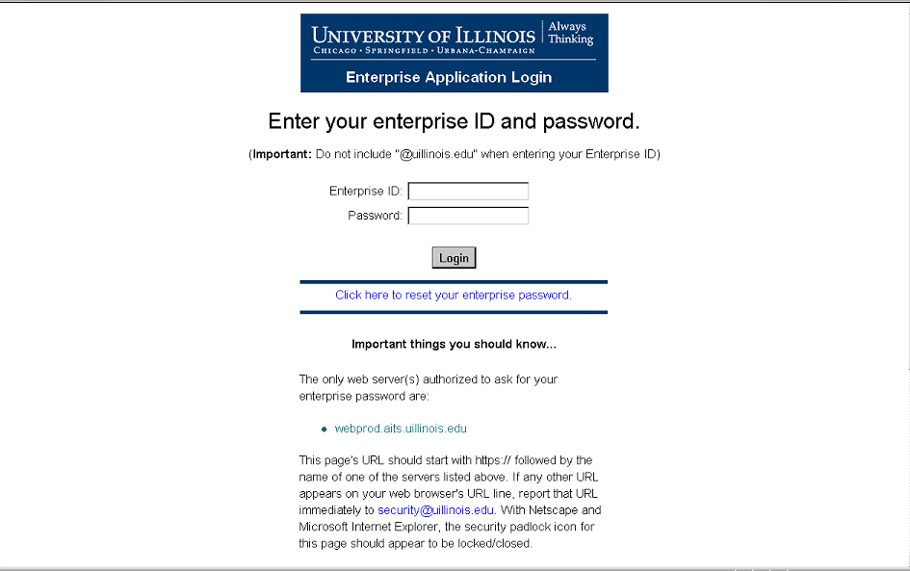

The EAS authentication Page authenticates the user to provide access to the new PDL Setup and OAR/College user Pages. This login and campus code must be retained throughout the user’s session.

The campus code will be derived from the association of the Banner Login ID and EAS Login ID. The user’s campus will be derived from querying Banner’s GURUSRI table and getting the GURUSRI_VPDI_CODE field’s value(s). The first character of the GURUSRI_VPDI_CODE field’s value (i.e., Urbana (‘1UIUC’ = ‘1’), Chicago (‘2UIC’ = ‘2’) and Springfield (‘4UIS’ = ‘4’)) will determine the campus associated with the user.

If the user has one GURUSRI_VPDI_CODE, the one value will be returned to the PDL application. This value will be used to bring back the correct term code from the STVTERM table. If the GURUSRI_VPDI_CODE begins with a “1”, terms from the STVTERM table beginning with a “1” will be returned. For example, if the GURUSRI_VPDI_CODE begins with a ‘1’, the terms retrieved from STVTERM will be ‘120048’, ‘120058’, etc.

If the user has multiple GURUSRI_VPDI_CODE’s, the multiple values will be returned to the PDL application. These values will be used to bring back the correct term codes from the STVTERM table. If the GURUSRI_VPDI_CODE begins with a ‘1’ and a ‘2’, terms from the STVTERM table beginning with a “1” and a “2” will be returned. For example, if the GURUSRI_VPDI_CODE begins with a ‘1’ and a ‘2’, the terms retrieved from STVTERM will be ‘120048’, ‘120058’, “220048”, “22058”, etc.

Pending Degree Initial Page

Page Description
This page will be displayed after the user has been authenticated through EAS. Appropriate OAR/College users will be able to Select Campus and access Setup Pages and the Add/Search Pages from this page.

Page Layout
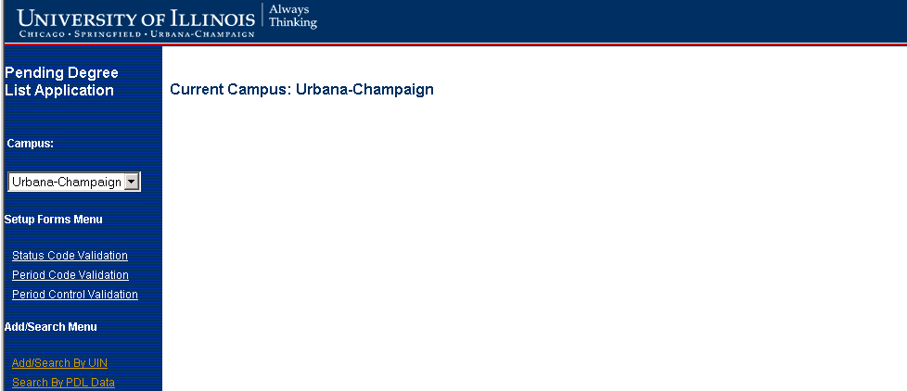

Page Controls
(Note: The links on the left navigation bar are available on all of the PDL pages. The descriptions below will not be repeated for all the pages)

List Box | Description
Campus | Allows user to select Campus. (If user has access to only one campus then only one campus will be displayed in list box)
Links | Description
Status Code Validation | If the user clicks the Status Code Validation link, the Status Code Validation summary page will be displayed.
Period Code Validation | If the user clicks the Period Code Validation link, the Period Code Validation summary page will be displayed.
Period Control Validation | If the user clicks the Period Control Validation link, the Period Control Validation summary page will be displayed.
Add/Search By UIN | If the user clicks the Add/Search By UIN link, the Add/Search By UIN page will be displayed.
Search By PDL Data | If the user clicks the Search By PDL Data link, the Search By PDL Data page will be displayed.

OAR/COLLEGE PAGES

Add/Search By Student UIN Page

Page Description
This page will be displayed if the user clicks the Add/Search By UIN link on the left navigation bar of any of the Pending Degree List pages. This page allows the user to enter selection criteria to display record(s) on the Pending Degree Detail Page.

Page Layout
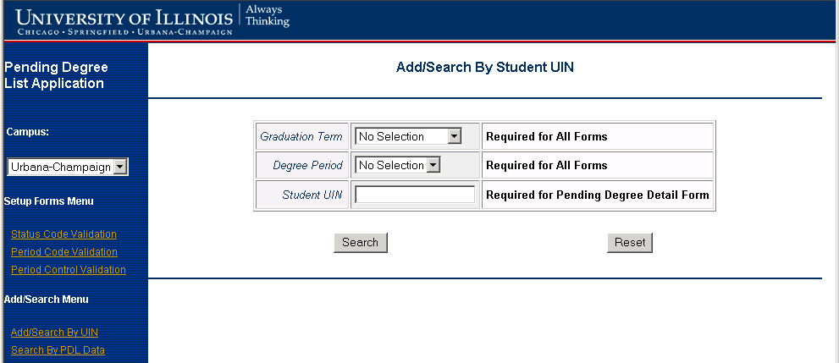

Page Field Description/Source/Comments
Field Name | Field Description | Field Source/Comments
Graduation Term | This field will contain a list of valid graduation terms from which the user can select a value. | Only terms listed on the Pending Degree Period Control Validation table (T_SZVDPCT) for the VPDI code of the user will be displayed
Degree Period | This field will contain a list of valid degree periods from which the user can select a value | Only period codes on the Pending Degree Period Control Validation table (T_SZVDPCT) associated with the Graduation Term selected will be displayed
Student UIN | This field allows the user to enter a Student UIN

Page Edits
After the user clicks the Search button, a check is done to ensure the Graduation Term and Degree Period have been selected and that a UIN has been entered.
If all required fields have been entered and the Search button is clicked, a check is performed on the Banner Personal Identification Table (SPRIDEN) to see if an entry with the Student UIN exists. If an entry does not exist on SPRIDEN, an error message will be displayed. If an entry exists on SPRIDEN, a check is done to see if an entry on the Pending Degree Master Table (T_SZRDGMR) with the UIN exists for the Graduation Term and Degree Period entered. If a record exists on T_SZRDGMR, the Pending Degree Detail Page is displayed in edit mode with the fields defaulted with values Page the T_SZRDGMR record. If a record is not found on T_SZRDGMR, the Pending Degree Detail Page is displayed in Add mode with selection values selected/entered for Graduation Term, Degree Period and Student UIN defaulted. The degree sequence will be defaulted to 1. Student name will be defaulted based on the Student UIN entered from the Banner Personal Identification Table (SPRIDEN).

Page Buttons
Button | Description
Search | If the user clicks the Search Button, the Pending Degree Master table is searched for entries matching the selection criteria entered. If matching records are found, the Pending Degree Detail Page is displayed with the matching record. If no matching records are found, the Pending Degree Detail Page will be displayed with Graduation Term, Degree Period, Deg Seq, ID, Name, Graduation Year and Pending Degree status pre-populated.
Reset | If user clicks the Reset button, all values are cleared out except for graduation term.  (Note: This only works for values entered before Search button is clicked)

Page Messages
Page Message Description | Page Message Condition
Graduation Term And Degree Period are Required Fields | If user clicks the Search button without entering values for both Graduation Term and Degree Period
Must enter UIN when searching by UIN. | If user clicks the Search button without entering value for Student UIN
No match found in Banner for Student UIN entered | If the user enters a Student UIN that does not exist on a record on the Banner Personal Identification table (SPRIDEN) and clicks on the Search button
Changes made to the detail record on the main form were NOT saved. It will be necessary to reenter the changes and press the Save button before leaving the detail record. | If the user returns to Add/Search By UIN page without saving changes

Business Logic / Calculation Rules
The Graduation Term, Degree Period and UIN values will be stored and repopulated if a user clicks the Search button and the returns to the Add/Search By UIN page from the Pending Degree Detail Page.

Graduation Term, Degree Period and Student UIN are required fields. After entering selection criteria, the user will click on the Search button.

If a matching record is found on the Pending Degree Master Table (T_SZRDGMR) for the criteria entered, the Pending Degree Detail Information page is displayed in Edit mode.

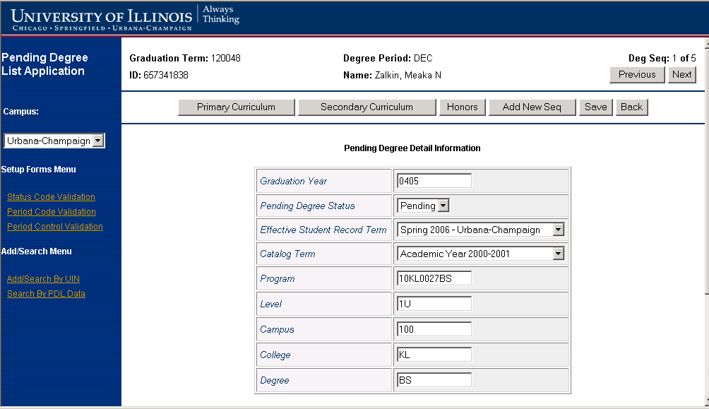



Note: If student has multiple degree records and/or multiple comments, these can be navigated using the previous and next buttons.

If no matching records are found on the Pending Degree Master Table (T_SZRDGMR) for the criteria entered, the Pending Degree Detail Information page is displayed in Add mode.

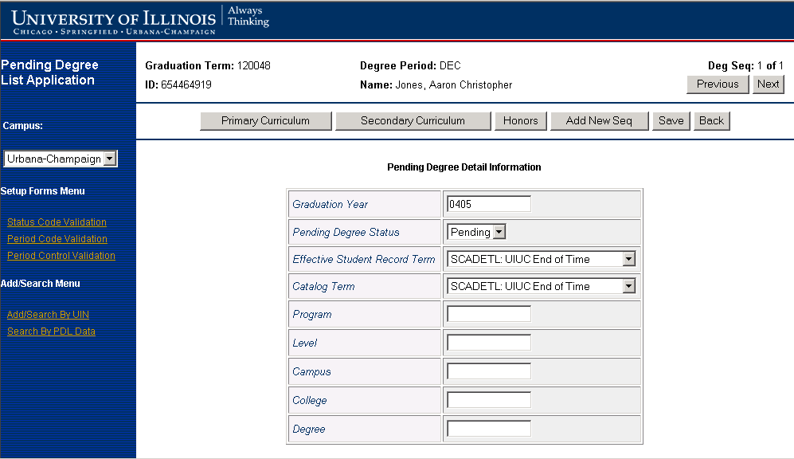

Search By Pending Degree Data Page

Page Description
This page will be displayed if the user clicks the Search By PDL Data link on the left navigation bar of any of the Pending Degree List pages. This page allows the user to enter selection criteria to display record(s) on either the Pending Degree Summary Page or the Pending Degree Detail Page.

Page Layout
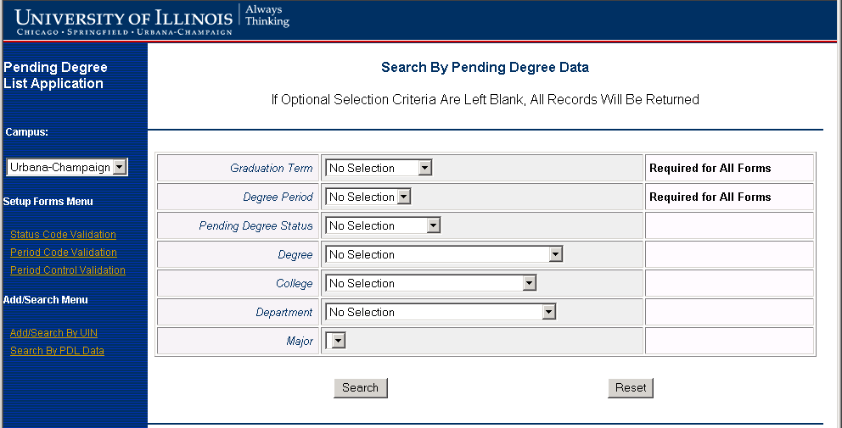

Page Field Description/Source/Comments
Field Name | Field Description | Field Source/Comments
Graduation Term | This field will contain a list of valid graduation terms from which the user can select a value. | Only terms listed on the Pending Degree Period Control Validation table (T_SZVDPCT) for the VPDI code of the user will be displayed
Degree Period | This field will contain a list of valid degree periods from which the user can select a value | Only period codes on the Pending Degree Period Control Validation table (T_SZVDPCT) associated with the Graduation Term selected will be displayed
Pending Degree Status | This field will contain a list of valid pending degree statuses from which the user can select a value | Only entries from the Pending Degree Status Code Validation table (T_SZVDEGS) will be displayed
Degree | This field will contain a list of valid degree codes and degree descriptions from which the user can select a value | Only degree codes and descriptions from the Banner Degree Code Validation table (STVDEGC) will be displayed
College | This field will contain a list of valid college codes and descriptions from which the user can select a value | Only college codes and descriptions from the Banner College Validation table (STVCOLL) will be displayed
Department | This field will contain a list of valid department codes and descriptions from which the user can select a value | Only department codes and descriptions from the Banner Department Code Validation Table (STVDEPT) will be displayed
Major | This field will contain a list of valid major codes and descriptions from which the user can select a value | Only Major codes and descriptions from the Banner Curriculum Major Rules table (SORCMJR) will be displayed

Page Edits
Page Edits
After the user clicks the Search button, a check is done to ensure the Graduation Term and Degree Period have been selected.

Page Buttons
Button | Description
Search | If the user clicks the Search Button, the Pending Degree Master table is searched for entries matching the selection criteria entered. If matching records are found, the Pending Degree Summary Page is displayed with the matching records. If no matching records are found, the Search By Pending Degree Data Page will be redisplayed with a message indicating no records were found.
Reset | If user clicks the Reset button, all values are cleared out except for graduation term.  (Note: This only works for values entered before Search button is clicked)

Page Messages
Page Message Description | Page Message Condition
Graduation Term And Degree Period are Required Fields | If user clicks the Search button without entering values for both Graduation Term and Degree Period
No records found for criteria | If user clicks Search button and no records are found matching selection criteria

Business Logic / Calculation Rules
The Graduation Term and Degree Period a user selects will be stored and repopulated if a user clicks the Search button and returns to the Search By Pending Degree Data Page from either the Pending Degree Summary Page or the Pending Degree Detail Page. All other fields will not be repopulated.

If a multiple matching records are found on the Pending Degree Master Table (T_SZRDGMR) for the criteria entered, the Pending Degree Detail Information page is displayed in Edit mode.

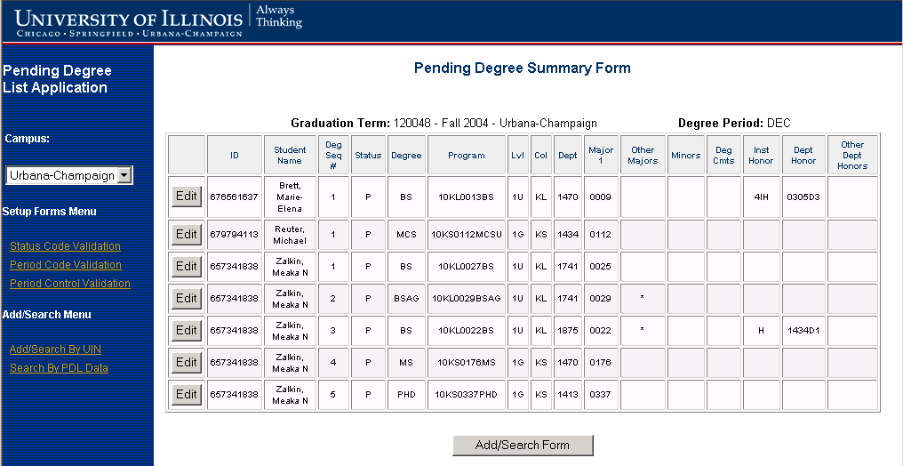

If only one matching record is found on the Pending Degree Master Table (T_SZRDGMR) for the criteria entered, the Pending Degree Detail Information page is displayed in Edit mode.

Note: If student has multiple degree records and/or multiple comments, these can be navigated using the previous and next buttons.

Pending Degree Summary Page

Page Description
This page will be displayed if the user clicks the Search button on the Search By Pending Degree Data Page and records matching the selection criteria entered are found. This will allow OAR/College users to view summary information matching selection criteria entered. The user will be able to view/edit detail information for a particular record on the Pending Degree Detail Page by clicking the Edit button associated with a summary record. This page is displayed in inquiry only mode with all fields protected.

Page Layout

Note: Records will be sorted by Last Name, First Name, Middle Initial, ID, and Degree Seq Number.

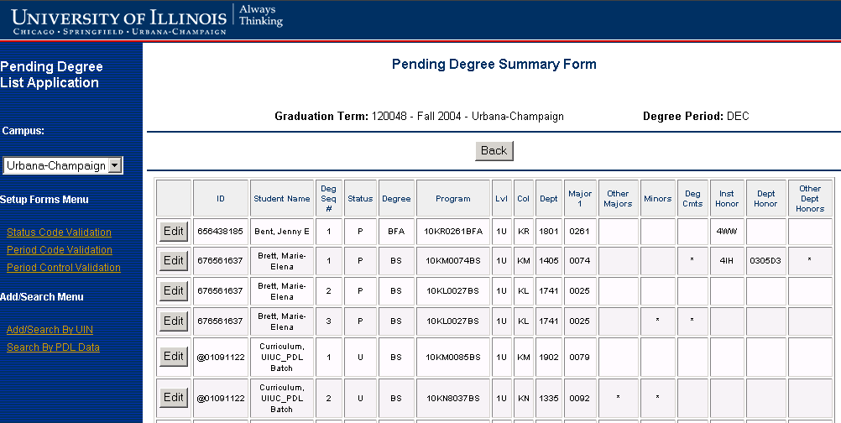

(Note: up to 10 matches will be displayed at a time. If there are more than 10 matches, the user will be able to navigate using previous and next buttons)

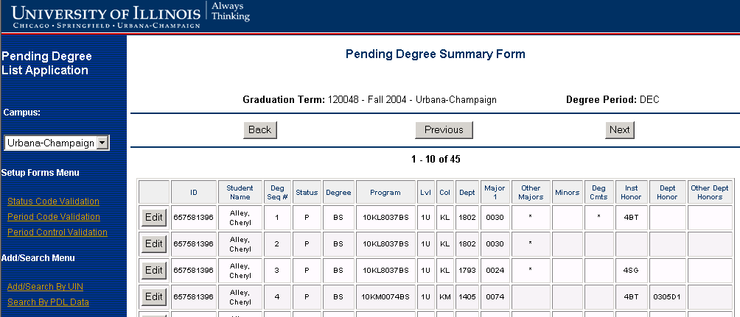

Page Field Description/Source/Comments
Field Name | Field Description | Field Source/Comments
Graduation Term | Graduation Term | SZRDGMR_TERM_CODE_GRAD
Degree Period | Degree Period | SZRDGMR_DEGP_CODE
ID | Student UIN | (SPRIDEN_ID where SZRDGMR_PIDM = SPRIDEN_PIDM)
Student Name | Student Name | SZRDGMR_STUDENT_NAME  (SPRIDEN_LAST_NAME, SPRIDEN_FIRST_NAME, SPRIDEN_MI  WHERE SZRDGMR_PIDM = SPRIDEN_PIDM)
Deg Seq # | Degree Sequence Number | SZRDGMR_SEQ_NO
Status | Pending Degree Status | SZRDGMR_STATUS_CODE
Degree | Degree Code | SZRDGMR_DEGC_CODE
Program | Program Code | SZRDGMR_PROGRAM
Lvl | Student Level | SZRDGMR_LEVL_CODE
Col | College Code | SZRDGMR_COLL_CODE_1
Dept | Department Code | SZRDGMR_DEPT_CODE
Major 1 | Major Code | SZRDGMR_MAJR_CODE_1
Other Majors | Indicates whether a student has more than one major | Display * IF SZRDGMR_MAJR_CODE_1_2, SZRDGMR_MAJR_CODE_2 OR SZRDGMR_MAJR_CODE_2_2 IS NOT NULL
Minors | Indicates whether a student has minors | Display * IF SZRDGMR_MAJR_CODE_MINR_1, SZRDGMR_MAJR_CODE_MINR_1_2, SZRDGMR_MAJR_CODE_MINR_2 OR SZRDGMR_MAJR_CODE_MINR_2_2 IS NOT NULL
Deg Cmts | Indicates whether a pending degree comments exist | Display * IF EXISTS IN T_SZRDGCM  WHERE SZRDGMR_PIDM = SZRDGCM_PIDM  AND SZRDGMR_SEQ_NO = SZRDGCM_DGMR_SEQ_NO  AND SZRDGMR_TERM_CODE_GRAD = SZRDGCM_DGMR_TERM_CODE_GRAD  AND SZRDGMR_DEGP_CODE = SZRDGCM_DGMR_DEGP_CODE
Inst Honor | Institutional Honor Code | SZRDGIH_HOND_CODE WHERE SZRDGMR_PIDM = SZRDGIH_PIDM  AND SZRDGMR_SEQ_NO = SZRDGIH_DGMR_SEQ_NO AND SZRDGMR_TERM_CODE_GRAD = SZRDGIH_TERM_CODE_GRAD
Dept Honor | Departmental Honor Code | SZRDGDH_HOND_CODE WHERE SZRDGMR_PIDM = SZRDGDH_PIDM  AND T_SZRDGMR_SEQ_NO = SZRDGDH_DGMR_SEQ_NO  AND SZRDGMR_TERM_CODE_GRAD = SZRDGDH_TERM_CODE_GRAD
Other Dept Honors | Indicates whether more than one departmental honor exists | Display * IF Select Count(*) from T_SZRDGDH > 0  Where SZRDGMR_PIDM = SZRDGDH_PIDM  AND SZRDGMR_SEQ_NO = SZRDGDH_DGMR_SEQ_NO  AND SZRDGMR_TERM_CODE_GRAD = SZRDGDH_TERM_CODE_GRAD

Page Buttons
Button | Description
Back | If the user clicks the Back button, the Search By Pending Degree Data Page will be displayed
Edit | If the user clicks the Edit button, the Pending Degree Detail Page will be displayed with data to allow user to edit data

Business Logic / Calculation Rules
The functions of the AITS developed Pending Degree Summary Page are as follows:

- View existing Pending Degree information.
- Select an existing pending degree record for updates when used in conjunction with the AITS developed Pending Degree Detail Page by clicking the Edit button next to the record to be edited.

Requirements/Assumptions
- PIDM will be available via Web Session.
- Curriculum information displayed is Primary Curriculum data.
- Only one Institutional Honor exists per pending degree honor.

Pending Degree Detail Page

Page Description
This page is displayed if the user clicks on the Search button on the Add/Search By Student UIN Page and a record matching the selection criteria is found. This page is also displayed if the user clicks on the edit button from the Pending Degree Summary Page. This page allows OAR/College users to view detail information.

Page Layout

Note: If more than one record exists for the graduation term and degree period, the records are displayed in degree sequence number order and can be viewed using the previous and next buttons.

Page Field Description/Source/Comments
Field Name | Field Description | Field Source/Comments
Graduation Term | Graduation Term | SZRDGMR_TERM_CODE_GRAD
Degree Period | Graduation Degree Period Code | SZRDGMR_DEGP_CODE
Deg Seq. # | Degree Sequence Number | SZRDGMR_SEQ_NO  Note: The total number of degree records will be displayed to indicate to user how many degree records exist. User will access each degree seq # by using Previous and Next buttons.
ID | Student ID | SPRIDEN_ID where SZRDGMR_PIDM = SPRIDEN_PIDM
Name | Student Name | SPRIDEN_LAST_NAME, SPRIDEN_FIRST_NAME, SPRIDEN_MI  WHERE SZRDGMR_PIDM = SPRIDEN_PIDM
Graduation Year | Academic Graduation Year | SZRDGMR_ACYR_CODE
Pending Degree Status | Pending Degree Record Status | SZRDGMR_STATUS_CODE  This field cannot be updated if the value is equal to “U”.
Effective Student Record Term | Term student record is effective | SZRDGMR_TERM_CODE_STUREC  (List box should be populated with values from stvterm for the current campus)
Year | Academic Year of Effective Student Record Term | SZRDGMR_ACYR_CODE_BULLETIN
Catalog Term | Catalog effective term | SZRDGMR_TERM_CODE_CTLG_1  (List box should be populated with values from stvterm for the current campus)
Program | Program Code | SZRDGMR_PROGRAM  User will obtain program code from General Student Record in Banner.  Level, Campus, College and Degree will be defaulted based on Program code.
Level | Student Level | SZRDGMR_LEVL_CODE
Campus | Campus Code | SZRDGMR_CAMP_CODE
College | College Code | SZRDGMR_COLL_CODE_1
Degree | Degree Code | SZRDGMR_DEGC_CODE
Degree Comment | Degree Comments | SZRDGCM_COMMENT  All records from T_SZRDGCM that match the PIDM, sequence number, term and degree period of the pending degree record. Sort by SZRDGCM_SEQNO

Page Edits
Curriculum changes need to be validated. Refer to Appendix A Curriculum Validation for details.

Page Buttons
Button | Description
Primary Curriculum | If the user clicks the Primary Curriculum button, the Primary Curriculum Page will be displayed. If no primary curriculum info exists Page will be in add mode. If primary curriculum does exist the Page will be in edit mode.
Secondary Curriculum | If the user clicks the Secondary Curriculum button, the Secondary Curriculum Page will be displayed. If no secondary curriculum info exists Page will be in add mode. If secondary curriculum does exist the Page will be in edit mode.
Honors | If the user clicks the Honors button, the View/Maintain Honors Page will be displayed
Add New Seq | If the user clicks the Add New Seq button, Pending Degree Detail Page will be redisplayed  with the next available sequence number and the Graduation Term, Degree Period, ID, Name and Graduation Date defaulted.
Save | If the user clicks the Save button, changes will be saved and a message will be displayed.
Back | If the user clicks the Back button, the Page from which the Pending Degree Detail Page was accessed from will be displayed.

Page Messages
Page Message Description | Page Message Condition
Changes Saved | If the user makes changes to status(es), clicks the Save button and changes were successfully saved to the Pending Degree Master table ((T_SZRDGMR)).
Error Occurred Saving Changes | If an error occurred attempting to save status changes to the Pending Degree Master table ((T_SZRDGMR)).

Business Logic / Calculation Rules
The Pending Degree List Detail Page will serve the following purposes:
- Insert a new pending degree record into the Pending Degree Master table (T_SZRDGMR) as needed (late student notifications, additional degree(s) being awarded, etc.) for a specific student for a term and degree period.
- Make additional updates to a student’s specific pending degree record within the T_SZRDGMR table that are not allowed within the Degree Summary Page:
- Add or remove minors or concentrations.
- Perform a curriculum change to the pending degree record.
NOTE: This will not change the curriculum of the student. This will only change the curriculum for the pending degree record. If a student is expecting to earn an additional degree from another college, a new pending degree record will need to be created for the student rather than changing the curriculum on the existing pending degree record.
- Change the majors within a multiple major program.
- Add or remove pending degree comments.
No changes to any pending degree information will be allowed when the pending degree status code = ‘U’ (Updated in Banner) other than inserts of pending degree comments.
The user ID field (SZRDGMR_USER_ID) and activity date field (SZRDGMR_ACTIVITY_DATE) will be updated each time a change is made.

The Application Date (SZRDGMR_APPL_DATE) must be populated with system date for newly created T_SZRDGMR records.

If the user selects/enters Graduation Term, Degree Period and Student UIN on the Add/Search Page and clicks the Search button, a search is performed for matching records on the Pending Degree Master (T_SZRDGMR) table for the Graduation Term, Degree Period and Student UIN. If no matching records are found, the Pending Degree Detail Page will be displayed in add mode. The Pending Degree Detail Page will also be displayed in add mode if the user clicks on the Add New Seq button from the Pending Degree Detail Page in edit mode.

The selection values entered for Graduation Term, Degree Period and Student UIN on the Add/Search Page will be defaulted. The Name will be defaulted using a query similar to the following on the Banner Personal Identification table (SPRIDEN):

Select spriden_last_name, spriden_first_name, spriden_mi from spriden where spriden_id = <Student UIN Entered on Add/Search Page>

Assumptions
- All college offices will be able to retrieve degree records from another college office. There is not a requirement to restrict the updating of the pending degree records across college offices.

- If student has more than one degree record, the first degree sequence will be displayed. User will scroll through the degree sequences.

Primary Curriculum Page

Page Description
This page will be displayed if the user clicks on the Primary Curriculum button from the Pending Degree Detail Page. It will allow authorized users to view/update primary curriculum of pending degree record for a given degree sequence, graduation term and degree period.

Page Layout
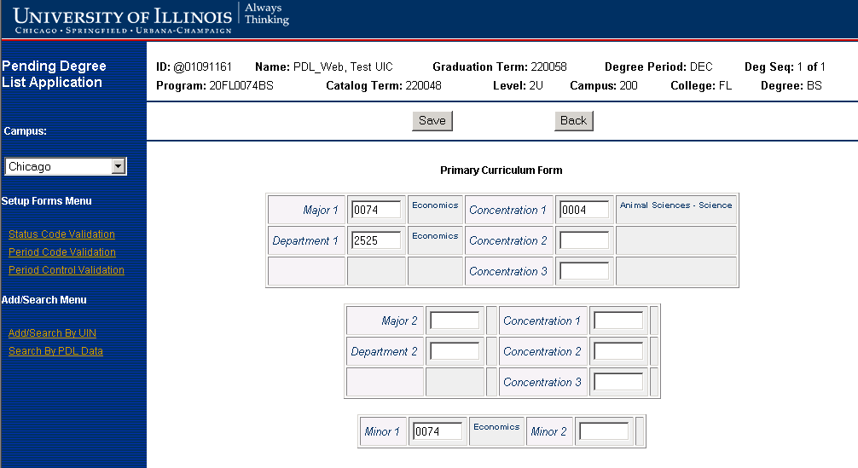

Page Field Description/Source/Comments
Field Name | Field Description | Field Source/Comments
ID | Student ID | SPRIDEN_ID where SZRDGMR_PIDM = SPRIDEN_PIDM
Name | Student Name | SPRIDEN_LAST_NAME, SPRIDEN_FIRST_NAME, SPRIDEN_MI  WHERE SZRDGMR_PIDM = SPRIDEN_PIDM
Graduation Term | Student Graduation Term | SZRDGMR_TERM_CODE_GRAD
Degree Period | Graduation Degree Period | SZRDGMR_DEGP_CODE
Deg Seq | Degree Sequence Number | SZRDGMR_SEQ_NO
Program | Program Code | SZRDGMR_PROGRAM
Catalog Term | Catalog Term | SZRDGMR_TERM_CODE_CTLG_1  SZRDGMR_TERM_CODE_CTLG_2  If no more than two majors or minors are being earned on a single pending degree record, the SZRDGMR_TERM_CODE_CTLG_2 field will be null. If more than two majors or minors are being earned, the PDL user will access the secondary curriculum block of the AITS developed Pending Degree List Detail Page to enter the major or minor code(s). The PDL user will not be allowed to enter any catalog term other than the catalog term stored in the SZRDGMR_TERM_CODE_CTLG_1 field for the same PIDM, program code, degree code and level code.
Level | Student Level | SZRDGMR_LEVL_CODE
Campus | Campus Code | SZRDGMR_CAMP_CODE
College | College Code | SZRDGMR_COLL_CODE_1
Degree | Degree Code | SZRDGMR_DEGC_CODE
Major1 | First Major | SZRDGMR_MAJR_CODE_1
Department1 | First Department | SZRDGMR_DEPT_CODE
Concentration1 | First Major Concentration 1 | SZRDGMR_MAJR_CODE_CONC_1
Concentration2 | First Major Concentration 2 | SZRDGMR_MAJR_CODE_CONC_1_2
Concentration3 | First Major Concentration 3 | SZRDGMR_MAJR_CODE_CONC_1_3
Major2 | Second Major | SZRDGMR_MAJR_CODE_1_2
Department2 | Second Department | SZRDGMR_DEPT_CODE_1_2
Concentration1 | Second Major Concentration 1 | SZRDGMR_MAJR_CODE_CONC_121
Concentration2 | Second Major Concentration 2 | SZRDGMR_MAJR_CODE_CONC_122
Concentration3 | Second Major Concentration 3 | SZRDGMR_MAJR_CODE_CONC_123
Minor1 | First Minor | SZRDGMR_MAJR_CODE_MINR_1
Minor2 | Second Minor | SZRDGMR_MAJR_CODE_MINR_1_2

Note: Descriptions for concentration, minor and major entries are obtained from STVMAJR (STVMAJR_DESC)
Descriptions for departments are obtained from STVDEPT (STVDEPT_DESC)

Page Edits
Curriculum changes need to be validated. Refer to Appendix A Curriculum Validation for details.

Page Buttons
Button | Description
Save | If the user clicks the Save button, the changes will be saved and the Pending Degree Detail List Page will be displayed
Back | If the user clicks the Back button, the Pending Degree Detail List Page will be displayed

Business Logic / Calculation Rules
The user ID field (SZRDGMR_USER_ID) and activity date field (SZRDGMR_ACTIVITY_DATE) will be updated each time a change is made. Refer to Appendix A Curriculum Validation.

Assumptions
All college offices will be able to retrieve degree records from another college office. There is not a requirement to restrict the updating of the pending degree records across college offices.

Secondary Curriculum Page

Page Description
This Page will be displayed if the user clicks on the Secondary Curriculum button from the Pending Degree Detail Page. It will allow authorized users to view/update secondary curriculum of pending degree record for a given degree sequence, graduation term and degree period.

Page Layout
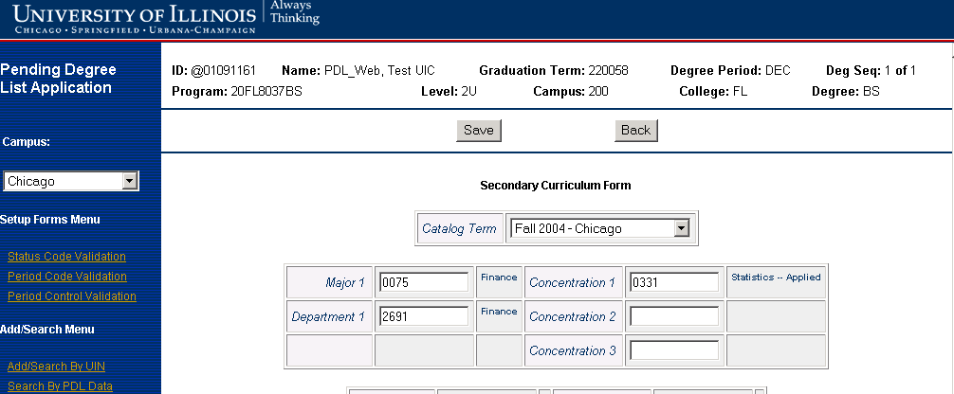

Page Field Description/Source/Comments
Field Name | Field Description | Field Source/Comments
ID | Student ID | SPRIDEN_ID where SZRDGMR_PIDM = SPRIDEN_PIDM
Name | Student Name | SPRIDEN_LAST_NAME, SPRIDEN_FIRST_NAME, SPRIDEN_MI  WHERE SZRDGMR_PIDM = SPRIDEN_PIDM
Graduation Term | Student Graduation Term | SZRDGMR_TERM_CODE_GRAD
Degree Period | Graduation Degree Period | SZRDGMR_DEGP_CODE
Deg Seq | Degree Sequence Number | SZRDGMR_SEQ_NO
Program | Program Code | SZRDGMR_PROGRAM
Level | Student Level | SZRDGMR_LEVL_CODE
Campus | Campus Code | SZRDGMR_CAMP_CODE_2  If no more than two majors or minors are being earned on a single pending degree record, this field will be null. If more than two majors or minors are being earned, the PDL user will access the secondary curriculum block of the AITS developed Pending Degree List Detail Page to enter the major or minor code(s). The PDL user will not be allowed to enter any campus code in the key block other than the campus code found on the Banner Base Curriculum Rules Table (SOBCURR) table matching the student’s pending degree record program code (SZADGMR_PROGRAM). If the user neglects to populate the campus code in the key block, the Page will default the campus code using the campus code found on the SOBCURR table matching the student’s pending degree record program code (SZADGMR_PROGRAM).
College | College Code | SZRDGMR_COLL_CODE_2  If no more than two majors or minors are being earned on a single pending degree record, this field will be null. If more than two majors or minors are being earned, the PDL user will access the secondary curriculum block of the AITS developed Pending Degree List Detail Page to enter the major or minor code(s). The PDL user will not be allowed to enter any college code in the key block other than the college code found on Banner Base Curriculum Rules Table (SOBCURR) matching the student’s pending degree record program code (SZADGMR_PROGRAM). If the user neglects to populate the college code in the key block, the Page will default the college code using the college code found on the SOBCURR table matching the student’s pending degree record program code (SZADGMR_PROGRAM).
Degree | Degree Code | SZRDGMR_DEGC_CODE
Second Catalog Term | Catalog Term | SZRDGMR_TERM_CODE_CTLG_2 - If no more than two majors or minors are being earned on a single pending degree record, this field will be null. If more than two majors or minors are being earned, the PDL user will access the secondary curriculum block of the AITS developed Pending Degree List Detail Page to enter the major or minor code(s). The PDL user will not be allowed to enter any catalog term other than the catalog term stored in the SZRDGMR_TERM_CODE_CTLG_1 field for the same PIDM, program code, degree code and level code.
Major1 | First Major | SZRDGMR_MAJR_CODE_2
Department1 | First Department | SZRDGMR_DEPT_CODE_2
Concentration1 | First Major Concentration 1 | SZRDGMR_MAJR_CODE_CONC_2
Concentration2 | First Major Concentration 2 | SZRDGMR_MAJR_CODE_CONC_2_2
Concentration3 | First Major Concentration 3 | SZRDGMR_MAJR_CODE_CONC_2_3
Major2 | Second Major | SZRDGMR_MAJR_CODE_2_2
Department2 | Second Department | SZRDGMR_DEPT_CODE_2_2
Concentration1 | Second Major Concentration 1 | SZRDGMR_MAJR_CODE_CONC_221
Concentration2 | Second Major Concentration 2 | SZRDGMR_MAJR_CODE_CONC_222
Concentration3 | Second Major Concentration 3 | SZRDGMR_MAJR_CODE_CONC_223
Minor1 | First Minor | SZRDGMR_MAJR_CODE_MINR_2
Minor2 | Second Minor | SZRDGMR_MAJR_CODE_MINR_2_2

Note: Descriptions for concentration, minor and major entries are obtained from STVMAJR (STVMAJR_DESC)
Descriptions for departments are obtained from STVDEPT (STVDEPT_DESC)

Page Edits
Curriculum changes need to be validated. Refer to Appendix A Curriculum Validation for details.

Page Buttons
Button | Description
Save | If the user clicks the Save button, the changes will be saved and the Pending Degree Detail List Page will be displayed
Back | If the user clicks the Back button, the Pending Degree Detail List Page will be displayed

Business Logic / Calculation Rules
The secondary curriculum Page will function very much as the secondary curriculum within the SHADEGR Page in Banner. There is currently a defect within the secondary curriculum block of this Page in that the user is allowed to enter a college or campus that is not associated with the program code. Banner then ignores validation rules on SOBCURR associated with that program code. This logic will not be carried over to the PDL Page. Only college and campus matching program code of degree record will be allowed.

The user ID field (SZRDGMR_USER_ID) and activity date field (SZRDGMR_ACTIVITY_DATE) will be updated each time a change is made. Refer to Appendix A Curriculum Validation.

View/Maintain Honors

Page Description
This page will be displayed if the user clicks on the Honors button from the Pending Degree Detail Page. It will allow authorized OAR/College users to view/update Pending Degree Institutional Honors table (T_SZRDGIH) and Pending Degree Departmental Honors table (T_SZRDGDH) entries corresponding to the pending degree record for a given degree sequence, graduation term and degree period.

Page Layout
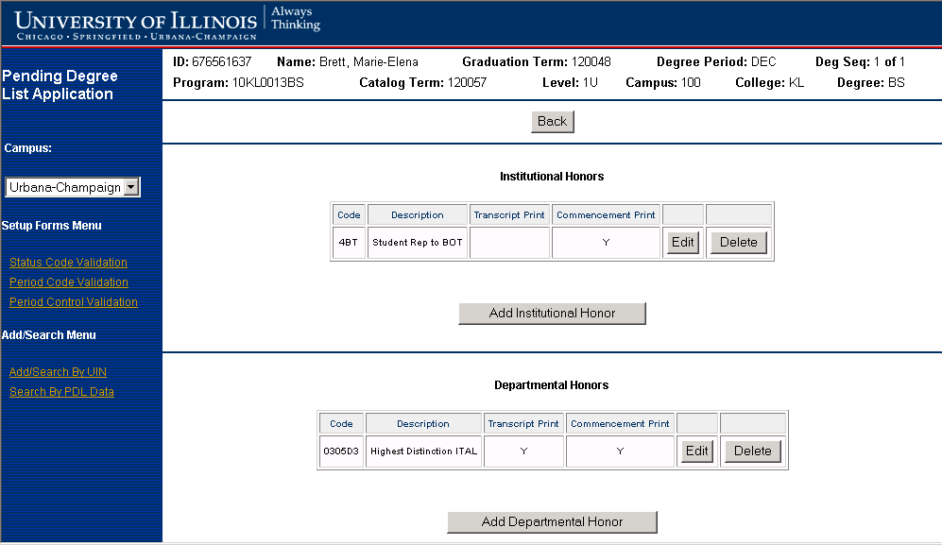

Page Field Description/Source/Comments
Field Name | Field Description | Field Source/Comments
ID | Student ID | SPRIDEN_ID where SZRDGMR_PIDM = SPRIDEN_PIDM
Name | Student Name | SPRIDEN_LAST_NAME, SPRIDEN_FIRST_NAME, SPRIDEN_MI  WHERE SZRDGMR_PIDM = SPRIDEN_PIDM
Graduation Term | Student Graduation Term | SZRDGMR_TERM_CODE_GRAD
Degree Period | Graduation Degree Period | SZRDGMR_DEGP_CODE
Deg Seq | Degree Sequence Number | SZRDGMR_SEQ_NO
Program | Program Code | SZRDGMR_PROGRAM
Catalog Term | Catalog Term | SZRDGMR_TERM_CODE_CTLG_1
Level | Student Level | SZRDGMR_LEVL_CODE
Campus | Campus Code | SZRDGMR_CAMP_CODE
College | College | SZRDGMR_COLL_CODE_1
Degree | Degree Code | SZRDGMR_DEGC_CODE

Page Field Mapping
Institutional Honors
All institutional honors that match the PIDM, pending degree sequence number, term and degree period of the pending degree record.

Field Name | Field Mapping/ Comments
Code | SZRDGIH_HONR_CODE  WHERE SZRDGMR_PIDM = SZRDGIH_PIDM  AND SZRDGMR_SEQ_NO = SZRDGIH_DGMR_SEQ_NO  AND SZRDGMR_TERM_CODE_GRAD = SZRDGIH_DGMR_TERM_CODE_GRAD  AND SZRDGMR_DEGP_CODE = SZRDGIH_DGMR_DEGP_CODE
Description | STVHONR_DESC WHERE SZADGIH_HONR_CODE = STVHONR_CODE
Transcript Print | SZRDGIH_TRANSC_PRT_IND = ‘Y’. This value is defaulted from the STVHONR table and is not updateable on the SZRDGIH table.
Commencement Print | SZRDGIH_COMMENCE_PRT_IND = ‘Y’. This value is defaulted from the STVHONR table and is not updateable on the SZRDGIH table.

Departmental Honors
All departmental honors that match the PIDM, pending degree sequence number, term and degree period of the pending degree record. Sort by SZRDGDH_HOND_CODE.

Field Name | Field Mapping/ Comments
Code | SZRDGDH_HOND_CODE  WHERE SZRDGMR_PIDM = SZADGDH_PIDM  AND SZRDGMR_SEQ_NO = SZADGDH_DGMR_SEQ_NO  AND SZRDGMR_TERM_CODE_GRAD = SZRDGDH_DGMR_TERM_CODE_GRAD  AND SZRDGMR_DEGP_CODE = SZRDGDH_DGMR_DEGP_CODE
Description | STVHOND_DESC WHERE SZADGDH_HOND_CODE = STVHOND_CODE
Transcript Print | SZRDGDH_TRANSC_PRT_IND = ‘Y’. This value is defaulted from the STVHOND table and is not updateable on the SZRDGDH table.
Commencement Print | SZRDGDH_COMMENCE_PRT_IND = ‘Y’. This value is defaulted from the STVHOND table and is not updateable on the SZRDGDH table.

Page Buttons
Button | Description
Back | If the user clicks the Back Button, the Pending Degree Detail Page will be displayed
Edit | If the user clicks the Edit Button, the selected honor record will be displayed for edit
Delete | If the user clicks the Delete Button, the selected honor record will be displayed for delete
Add Institutional Honor | If the user clicks the Add Institutional Honor Button, the Add Institutional Honor Page will be displayed
Add Departmental Honor | If the user clicks the Add Departmental Honor Button, the Add Departmental Honor from will be displayed

Page Messages
Page Message Description | Page Message Condition
Unable to edit/delete record because record with honor code already exists on Pending Degree Master Table | If the user attempts to edit/delete the honor code on the Pending Degree Institutional Honors table (T_SZRDGIH) and/or Pending Degree Departmental Honors table (T_SZRDGDH) and a record on the Pending Degree Master Table (T_SZRDGMR) already contains the honor code value.
Record already exists with honor code already exists | If the user attempts to add an entry to the Pending Degree Institutional Honors table (T_SZRDGIH) and/or Pending Degree Departmental Honors table (T_SZRDGDH) that already exists.
Changes Saved | If the user makes changes (Add or Edit), clicks the Save button and changes were successfully saved to the Pending Degree Institutional Honors table (T_SZRDGIH) and/or Pending Degree Departmental Honors table (T_SZRDGDH)
Error Occurred Saving Changes | If an error occurred attempting to save changes to the Pending Degree Institutional Honors table (T_SZRDGIH) and/or Pending Degree Departmental Honors table (T_SZRDGDH)

Business Logic / Calculation Rules
Note: The Transcript Print and Commencement Print values are defaulted and cannot be changed.

If a user clicks the Edit button to edit an existing Institutional Honors record, the institutional honors portion of the Honors page will be displayed in edit mode to allow the record to be edited:

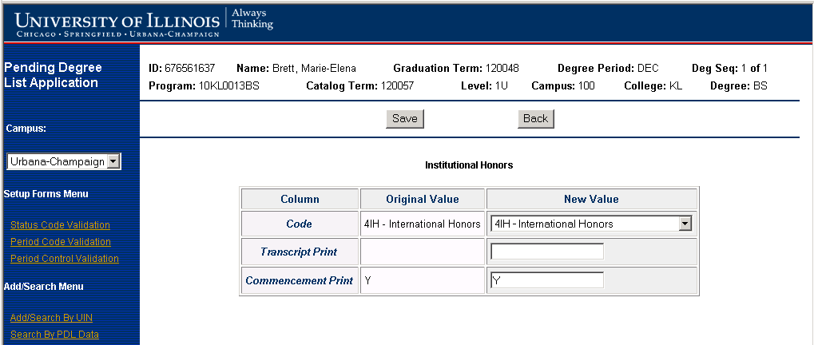

If a user clicks the Edit button to edit an existing Departmental Honors record, the departmental honors portion of the Honors page will be displayed in edit mode to allow the record to be edited:

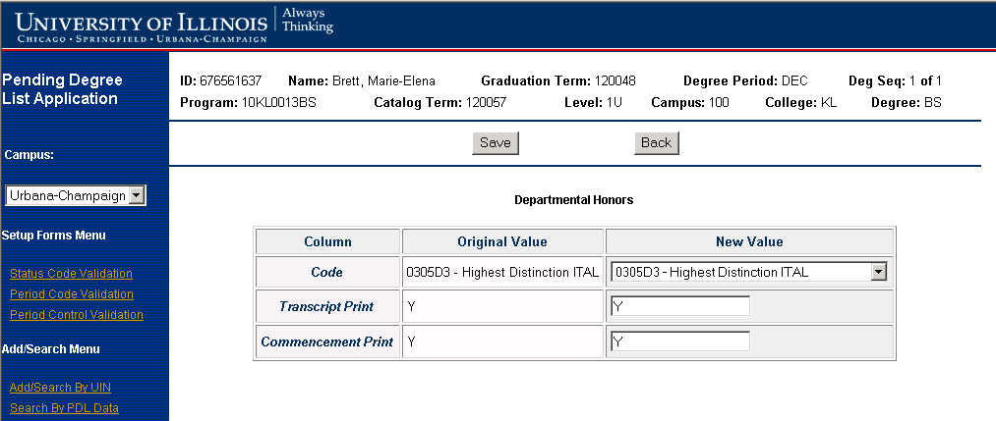

If a user clicks the Add Institutional Honors button, the institutional honors portion of the Honors page will be displayed in add mode to allow a new record to be entered:

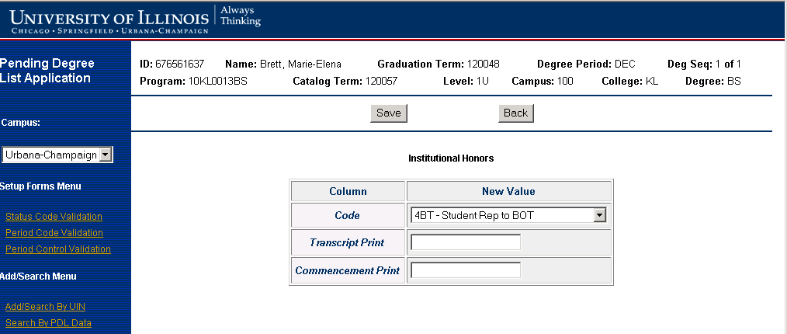

If a user clicks the Add Departmental Honors button, the departmental honors portion of the Honors page will be displayed in add mode to allow a new record to be entered:

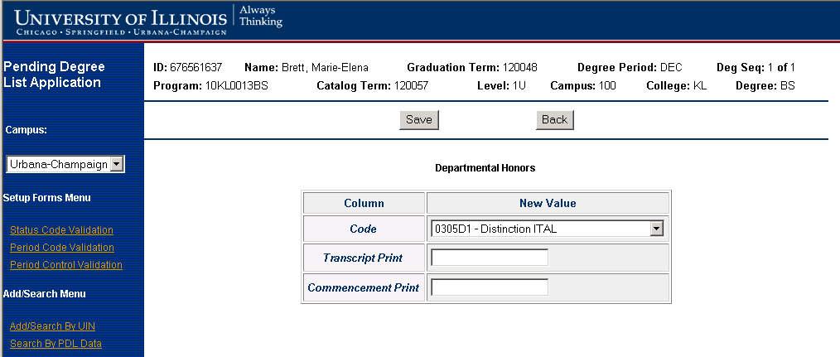

If a user clicks the Delete Institutional Honors button, the institutional honors portion of the Honors page will be displayed in delete mode to allow a record to be deleted:

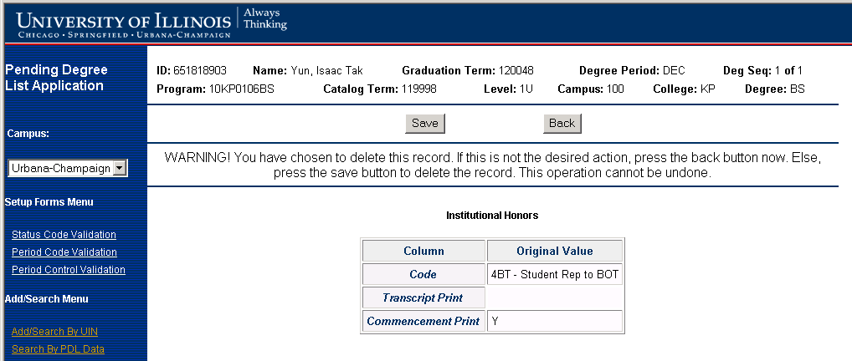

If a user clicks the Delete Departmental Honors button, the departmental honors portion of the Honors page will be displayed in delete mode to allow a record to be deleted:

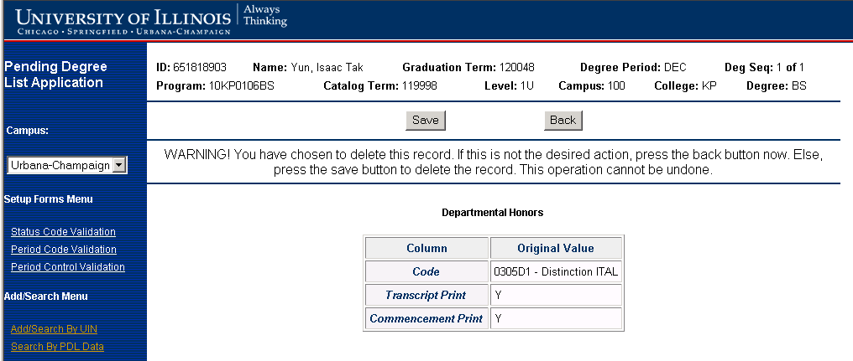
If user clicks the Save button, the Honors Page will be redisplayed with changes reflected and a message indicating the changes were saved:

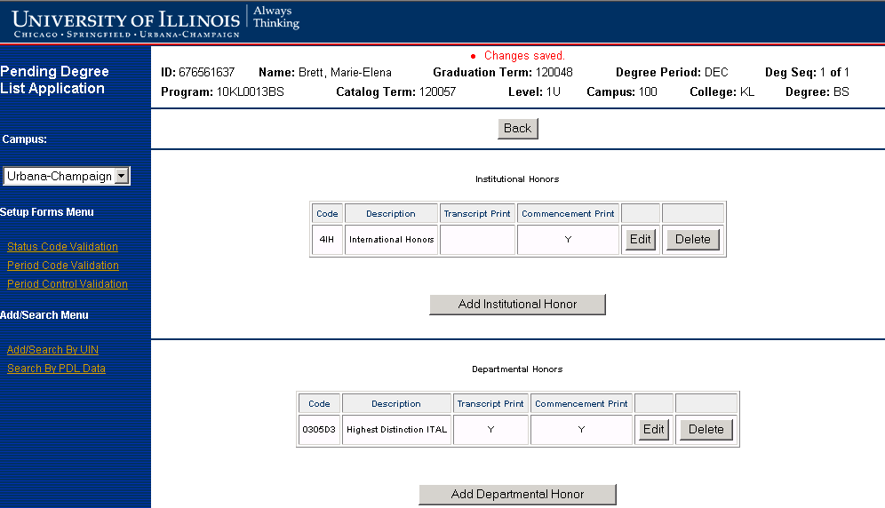

If user clicks the Back button, any changes are not saved and the Honors Page will be redisplayed:

BANNER STUDENT WEB SELF SERVICE PAGES

The UI2 web team will create a new Banner Student Self Service web page named Graduation Information. The Graduation Information web page will contain graduation information specific to the campus associated with the student’s user id. The text displayed on the Graduation Information page is stored in Web Tailor. A link to the Graduation Information Page will be added to the Banner Student Web Self Service Main Menu. The Graduation Information link will also appear at the top of all the Record and Registration Banner Web Self Service pages.

The Graduation Information web page displayed for the Chicago and Urbana campuses will contain a link called Notify Intent to Graduate This Term if there are entries on the Pending Degree Period Control Validation Table (T_SZVDPCT) that match the campus code associated with the student and for which the system date is in between the Web Entry Begin date and Web Entry End date values. The Springfield campus will continue to process pending degree list data manually and thus will not contain this link. If the Notify Intent to Graduate This Term link is clicked, the AITS developed Select Pending Degree web page will be displayed which allows a student to select the graduation term and degree period s/he intends to graduate.

Once the student has selected the graduation term and degree period s/he intends to graduate on the Select Pending Degree web page and clicks the Submit button, the AITS developed Add Pending Degree Web Page containing degree information retrieved from the Banner General Student (SGBSTDN) table will be displayed. Once the student clicks the Submit button a record is written to the Pending Degree Mater table (T_SZRDGMR).

Banner Student Web Self Service Main Menu

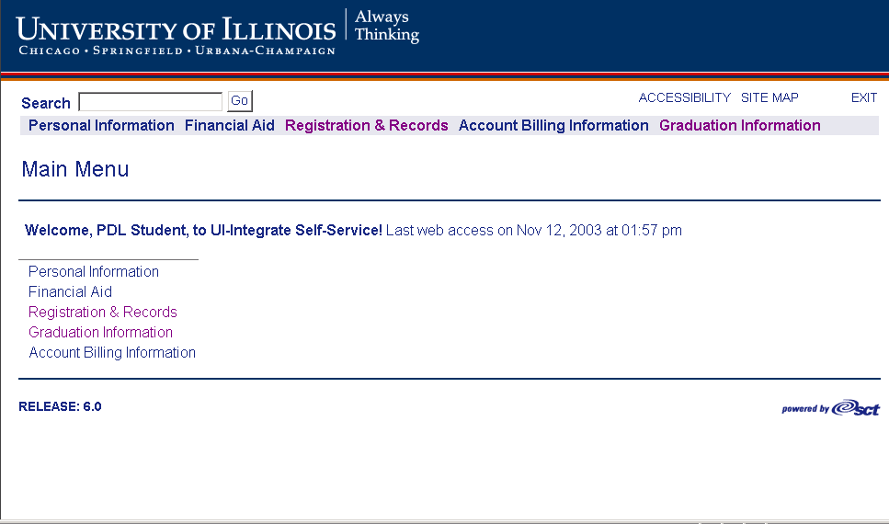

Graduation Information Web Page (Urbana Campus)

Note: The Notify Intent to Graduate This Term link will only appear if valid entries exist on T_SZVDPCT

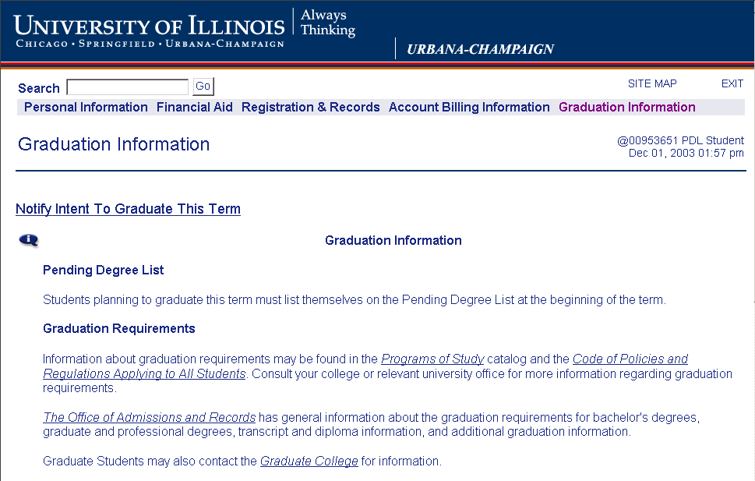
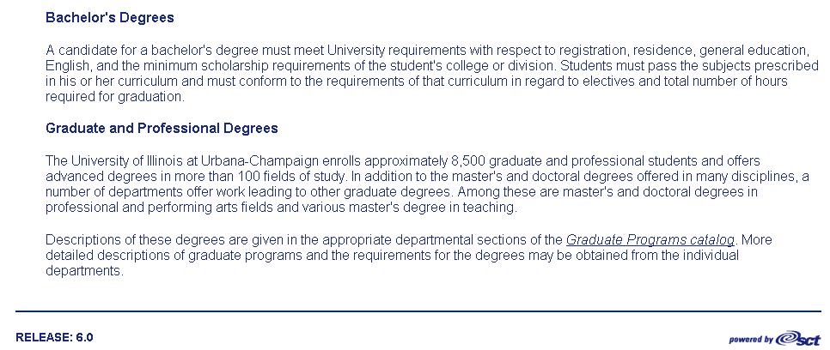

The new Web pages should follow the look and feel of the Banner Web Self Service Pages.

Select Pending Degree Graduation Term Web Page

Page Description
This Page is accessed via the Notify Intent To Graduate This Term link on the Graduation Information web page. It allows a student to select the Graduation Term, which s/he intends to graduate.

Page Layout
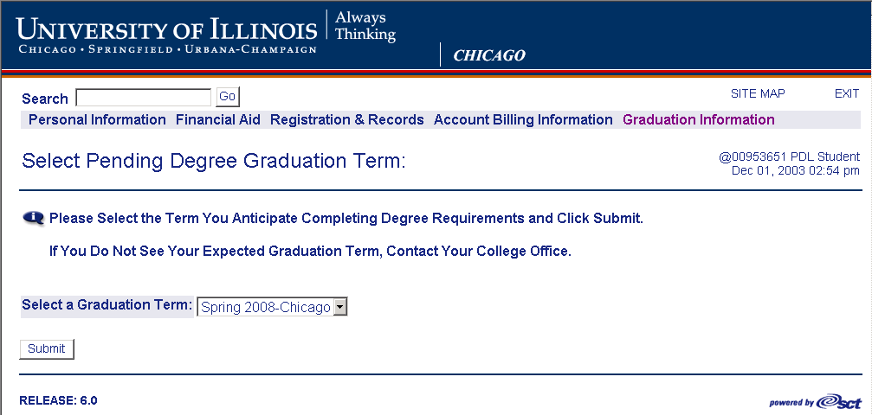

Page Field Description
Field Name | Field Description
Graduation Term | This field contains the expected graduation term

Field Edits
Field | Edit
Graduation Term | Only display entries for which current date is greater than or equal to the begin date (SZVDPCT_BEGIN_DATE) and less than or equal to the end date (SZVDPCT_CUTOFF_DATE) on the Pending Degree Period Control table (T_SZVDPCT) for the campus associated with the student.

Page Buttons/Links
Button | Description
Submit | If the user clicks the Submit button, the Select Pending Degree Period Web Page will be displayed.

Page Security
Access to this Page will be available to EAS authenticated students

Business Logic / Calculation Rules
Refer to Page edits, Page buttons and Page messages.

After the Submit button is clicked, the Select Pending Degree Period Web Page is displayed with valid degree periods for the graduation term from the Pending Degree Period Control Validation Table (T_SZVDPCT) table.

Select Pending Degree Period Web Page

Page Description
This Page is accessed if a student clicks the Submit button on the Select Pending Degree Graduation Term Web Page. It allows a student to select the Degree Period within the Graduation Term in which s/he intends to graduate.

Page Layout
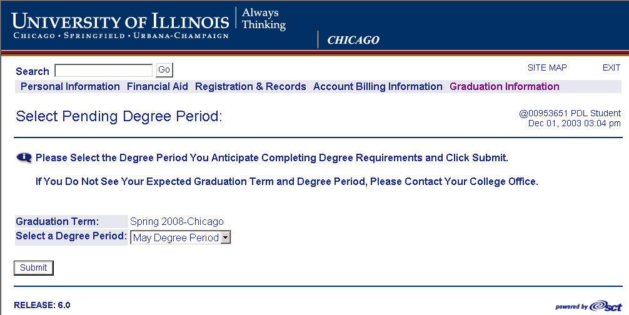

Page Field Description
Field Name | Field Description
Graduation Term | Contains the graduation term selected on the Select Pending Degree Graduation Term Web Page.
Degree Period | This field contains the expected degree graduation period

Field Edits
Field | Edit
Degree Period | Only valid Degree Periods on the Pending Degree Period Control Validation Table (T_SZVDPCT) table for the Graduation Term selected on the Select Pending Degree Graduation Term Web Page will be displayed.

Page Buttons/Links
Button | Description
Submit | If the user clicks the Submit button, the Add Pending Degree Web Page will be displayed

Page Messages
(Note: All Messages will be displayed on bottom of Page)

Page Message Description | Page Message Condition
You have already submitted a Pending Degree Request for the selected term and degree period.  If you have any questions or need to make changes please contact your college office or Records and Registration. | If Student clicks Continue button and record already exists in Pending Degree Master table (SZRDGMR) for the PIDM, term and degree period

Business Logic / Calculation Rules
Refer to Page edits, Page buttons and Page messages.

If the Submit button is clicked the Add Pending Degree Web Page will be displayed with
some of the General Student degree information based on the term and degree period selected by the student. The application will retrieve the information from the General Student where the SGBSTDN_EFF_TERM = term selected by the student OR MAX(SGBSTDN_EFF_TERM) < the term selected by the student.

Add Pending Degree Web Page

Page Description
This Page will be displayed if the Submit button is clicked on the Select Pending Degree Period Web Page. The degree information retrieved from the Banner General Student (SGBSTDN) table will be displayed. No updates will be allowed on this Page.

Page Layout
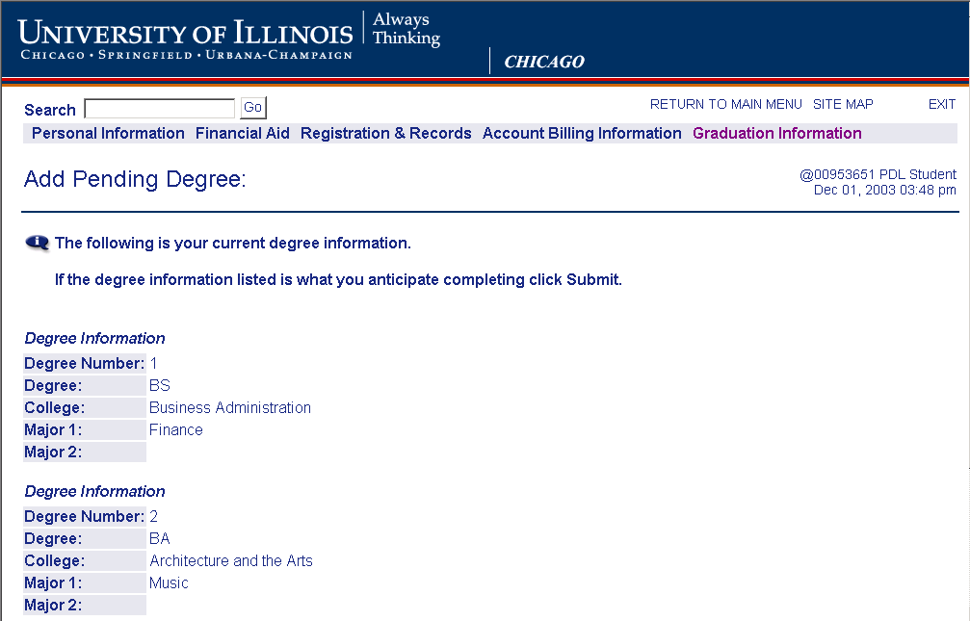



Page Field Description/Source/Comments
Field Name | Field Description | Field Source
Degree Number | The Degree Number | This will be based on number of degree records retrieved from Banner General Student Record (SGBSTDN)
Degree | Degree Code | SGBSTDN_DEGC_CODE_1  SGBSTDN_DEGC_CODE_2
College | Description of college that degree belongs to | SGBSTDN_COLL_CODE_1  SGBSTDN_COLL_CODE_2  Need to do look up for description that is stored in Banner College validation table (STVCOLL) (STVCOLL_CODE and STVCOLL_DESC)
Major1 | Major1 Description | SGBSTDN_MAJR_CODE_1  Need to do look up for description that is stored in Banner Curriculum Major Rules table (SORCMJR)  (SORCMJR_MAJR_CODE and SORCMJR _DESC)
Major2 | Major2 Description | SGBSTDN_MAJR_CODE_2  Need to do look up for description that is stored in Banner Curriculum Major Rules table (SORCMJR)  (SORCMJR_MAJR_CODE and SORCMJR _DESC)

Page Messages
(Note: All Messages will be displayed on bottom of Page)

Page Message Description | Page Message Condition
Your Graduation Information Has Been Successfully Recorded For the Above Graduation Term and Degree Period | If Student clicks on Submit button and record successfully built in Pending Degree Master table (SZRDGMR)
An Error Has Occurred Attempting to Record Your Graduation Information For the Above Graduation Term and Degree Period | If Student clicks on Submit button and record is not successfully built in Pending Degree Master table (SZRDGMR)

Page Buttons/Links
Button/Link | Description
Submit | If the user clicks the Submit button, a record is written to the pending degree master table (T_SZRDGMR) and a message is displayed indicating whether the insert is successful or not.
Return to Previous | If the user clicks the Return to Previous Link, the Select Pending Degree Web Page will be displayed.

Business Logic / Calculation Rules
The degree information returned to the student will be the descriptions, not the codes stored on the SGBSTDN table. The 2nd degree number will only be returned if the SGBSTDN_PROGRAM_2 field is non-null on the SGBSTDN table.

The Page will retrieve the degree information from the General Student Table (SGBSTDN) where the SGBSTDN_EFF_TERM = term entered by the student on the Select Pending Degree Web Page
OR MAX(SGBSTDN_EFF_TERM) < the term entered by the student on Select Pending Degree Web Page. From this page, the student will verify the degree information to be correct. If correct, the student will submit the degree information to be inserted to the PDL pending degree master table (T_SZRDGMR). The mapping of the record to be added to T_SZRDGMR is listed below.

If the Submit button is clicked, a check is performed to determine if a pending degree record exists for the PIDM, term and degree period. If no pending degree record exists, a pending degree record containing the degree information is inserted to the PDL pending degree table (SZRDGMR) and the web page is redisplayed with the following message:

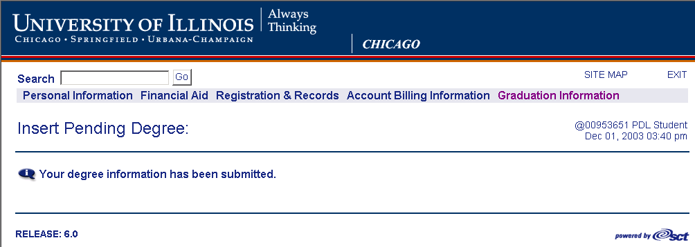

If a pending degree record exists, the web page will be redisplayed with the following error message.

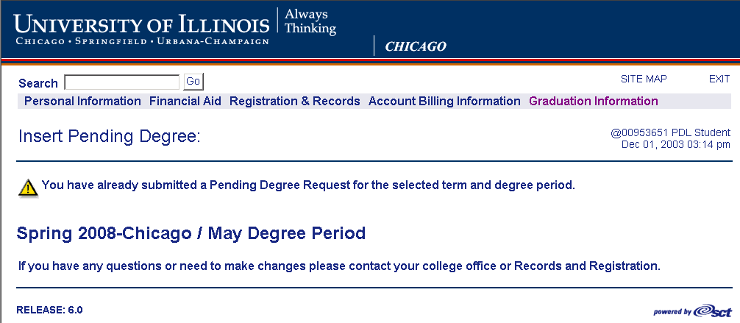:

If no match is found for the graduation term (to retrieve academic year) on STVTERM, the following error message will be displayed.

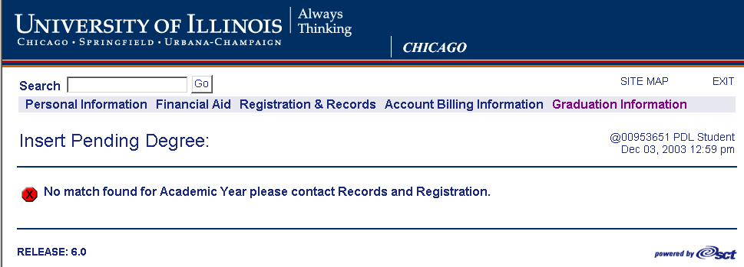
If the insert to T_SZRDGMR is not successful, the Page will be redisplayed and look similar to the following:

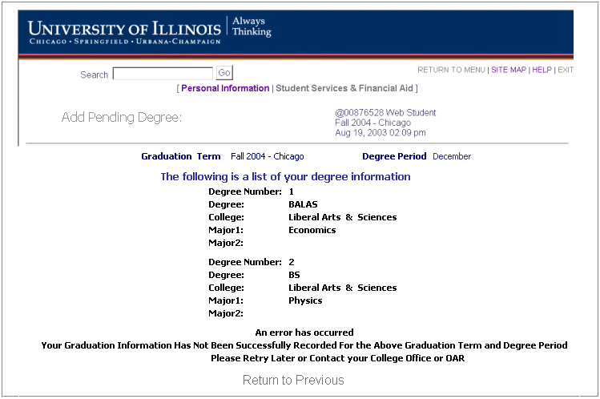

Batch Processing

Program Description
An automated batch process will be required to copy the certified pending degree records from the pending degree work tables to the banner production tables.

APPWORX will be the batch-scheduling tool used to process the PDL batch process. Two APPWORX chains will be established. One chain will execute the PDL batch process in Audit Mode and the other chain will execute the PDL process in Update Mode.

Audit mode will process a record normally, but instead of updating the Banner Pending Degree List tables Degree Table (SHRDGMR), Institutional Honors By Degree Table (SHRDGIH) and Departmental Honors By Degree Table (SHRDGDH), a report will be written showing the updates that will occur if Update mode were used. Update mode will process records and update the Banner Pending Degree List tables. Each process will consist of the following steps:

- The APPWORX job chain will kick off the PDL batch process that will copy records from the Pending Degree List work tables and insert them into the Banner Pending Degree List tables (Degree Table (SHRDGMR), Institutional Honors By Degree Table (SHRDGIH) and Departmental Honors By Degree Table (SHRDGDH))

- At the conclusion of the batch process, reports will be generated. (See Report section for details)

Frequency
It is anticipated that this process will execute on demand.

Parameters
The batch process will need to accept the following parameters:
Prompt  # | Prompt Name | Description
1 | Term to Process | This indicates the graduation term to select awarded degree records to copy to Banner
2 | Degree Period to Process | This indicates the degree period within the graduation period to select awarded degree records to copy to Banner
3 | Run Mode | This will indicate whether process is to be run in audit or update mode
Parameters will be maintained using “Parameter Editor”.

APPWORX
APPWORX will be the batch-scheduling tool used to initiate the PDL batch process. Two APPWORX chains will be established for the PDL batch process. One chain executes the PDL batch process in Audit Mode and the other chain will execute the PDL batch process in Update Mode.

The Audit Mode chain will contain a module that executes the PDL batch process passing it a parameter for Audit Mode. The PDL batch process will update T_PENDING_DEGREE_AUDIT, Error and Control Total tables. After the PDL batch process completes, the chain will execute modules that will produce the following SAS reports: Activity report, Control Total report, Potential Duplicate report and Error Report. Another module will move reports to Document Direct for viewing. The PDL batch process will need to accept a Mode parameter. (Either (A) Audit or (U) Update.

The Update Mode chain will contain a module that executes the PDL batch process passing it a parameter for Update Mode. The PDL batch process will update Banner Pending Degree List tables, Error and Control Total tables. After the PDL batch process completes, the chain will execute modules that will produce the following SAS reports: Activity report, Control Total report, Potential Duplicate report and Error Report. Another module will move reports to Document Direct for viewing.

Business Logic / Calculation Rules

(Note: This job will be available to run in Audit or Update mode. The difference between the two is explained below.)

Batch Processing Overview

- The batch process will start by removing records from the T_PENDING_DEGREE_AUDIT table that were inserted by previous batch process runs for the campus code and run mode parameter values.

- The batch process will retrieve the “Certified” (SZRDGMR_STATUS_CODE = ‘C’) pending degree records for campus code, the graduation term and degree period parameter values from the pending degree master table (T_SZRDGMR) along with any corresponding entries from the Pending Degree Departmental Honors Table (T_SZRDGDH) and Pending Degree Institutional Honors Table (T_SZRDGIH). These will be processed one by one using the steps below.

NOTE: Since it is possible for a student to earn more than one degree in a given term and degree period, there could be more than one “Certified” pending degree record for a given PIDM, term and degree period.

REMINDER! If batch process mode is run in audit mode, inserts to the Banner tables mentioned below are not performed.

- Check to make sure curriculum is valid by calling BANINST1.SOKCURR.P_CHECKCURRICULUM and BANINST1.SOKCMSG.F_CURRICULUMERRORMSG. Refer to Appendix A for details.

- If no errors occurred in step #3 insert record into corresponding Banner degree tables. (See data mapping).

  - Set SHRDGMR_DEGS_CODE = ‘AW’ to indicate awarded status.)
  - The Banner Degree Sequence Number will need to be calculated for each student’s Banner degree record before being inserted.

Since there could be more than one “Certified” pending degree record for a given PIDM, term and degree period, the calculation of the sequence number may vary. For the first insert for a given PIDM, the value for the sequence number should be MAX(SHRDGMR_SEQ_NO) +1. Batch process needs to check if the PIDM for the next record to be inserted is the same as the previous record inserted. If so, the sequence number value should be manually increased instead of using MAX(SHRDGMR_SEQ_NO) +1.
  - The Banner Degree Graduation Date (SHRDGMR_GRAD_DATE) will be retrieved from the Pending Degree Period Control table (T_SZVDPCT) for the degree period being processed.

Note: Before inserting into the Banner tables, the batch process will check for the existence of any “Awarded” degree records already in the Banner Degree Master table (SHRDGMR_DEGS_CODE = ‘AW’) matching the PIDM, level code and degree code of the “Certified” pending degree record(s) about to be inserted. If any matching awarded degree records exist in SHRDGMR, the process will write the pending degree record information to a duplicate table (T_PENDING_DEGREE_DUPLICATE). The pending degree record information will still be inserted into the Banner degree tables (see step below for details). A report will be generated and used by OAR to verify that the degree information awarded is not a duplicate degree. If any insert errors occur, an entry should be written to the T_Errorlog table and processing should continue.

- After the Banner Degree Sequence Number has been calculated and the pending degree record inserted into the Banner Degree table (SHRDGMR), any associated honors for the same degree period and graduation term will be copied from the PDL degree honors tables and inserted into the corresponding Banner degree honors table with the same degree sequence number calculated for the student’s new degree:
  - Departmental honors will be retrieved from T_SZRDGDH and inserted into SHRDGDH.
  - Institutional honors will be retrieved from T_SZRDGIH and inserted into SHRDGIH.

- Since this batch job will be run multiple times at the end of the graduation process, the process will need to update the pending degree status code on the T_SZRDGMR table to ‘U’ (Updated in Banner) once the degree has successfully been inserted. The purpose of this is to skip retrieving those records in subsequent runs. Also, the graduation date field on the Pending Degree Master table (SZRDGMR_GRAD_DATE) will need to be updated with the graduation date value on the Pending Degree Period Control Validation table (SZVDPCT_GRAD_DATE) for the Graduation Term and Degree parameter values used to execute the batch.

Note: If the entry for "U" Updated in Banner status on T_SZVDEGS is not found, an entry should be written to the T_Errorlog table and processing should stop.

- The batch job will write records Pending Degree Audit table (T_PENDING_DEGREE_AUDIT) for both audit and update modes.

  - If the job is run in Audit Mode, the batch process will write the student pending degree information that would have been inserted into the Banner degree tables (SHRDGMR, SHRDGDH, SHRDGIH). Any processing errors that may have been encountered will also be written to the T_ERRORLOG table.

  - If the job is run in Update Mode, the batch process will write the student pending degree information that was inserted into the Banner degree tables (SHRDGMR, SHRDGDH, SHRDGIH). The number of records read and the number of records inserted will be written to the T_Control_Totals table. Any processing errors that were encountered are written to the T_ERRORLOG table.

- After the final batch process has run for a given term and degree period, a final Pending Degree List report (designed by the reports team) will be run to show the status of all pending degree records. The PDL users may create new pending degree records in the following term and degree period for any student’s un-awarded pending degree records.

Reports To Be Generated By Report Team

Pending Degree List Report
This report will display the pending degree information from the pending degree tables regardless of the pending degree status code for a specific term and degree period.

Potential Attendee Commencement (UIC & UIUC)
This report will display all students with awarded degree records from either the summer or fall terms in the SHRDGMR table AND any pending degree records from the spring term PDL T_SZRDGMR table excluding any pending degree records with a “Deleted” degree status code.

Commencement Program Report (UIC & UIUC)
This report will display the degree information needed to print the commencement program. The degree information displayed will be retrieved from all awarded degree records from either the summer or fall terms in the Banner SHRDGMR table AND any pending degree records from the spring term PDL T_SZRDGMR table excluding any pending degree records with a “Deleted” degree status code.

Potential Bronze Tablet Recipients (UIUC)
This report will display all undergraduate students with awarded degree records from either the summer or fall terms in the SHRDGMR table AND any pending degree records from the spring term PDL T_SZRDGMR table excluding any pending degree records with a “Deleted” degree status code. The cumulative GPA of each student will also be included in the report.

Potential Bronze Tablet Recipients 110+ hours (UIUC)
This report will display all undergraduate students with 110+ earned hours and who are not on the spring term PDL T_SZRDGMR table. The cumulative GPA of each student will also be included in the report. This report and the Potential Bronze Tablet Recipients reports will need to be run the same day in order to include all students eligible to receive the Bronze Tablet honor.

General Student Primary/Secondary Curriculum vs. Student Degree Primary/Secondary Curriculum
Below is an example of a student pursuing two different degrees. The secondary curriculum on the General Student record becomes the primary curriculum of an additional degree record created in Banner. NOTE: If a student is pursuing more than two majors, the additional majors cannot be stored on the General Student record, only on the student degree record(s).

